**PROJECT 2**

**A Database for an Electronic**

**Medical Record System**

**Student Name: Banda Nitish Reddy**

**Student ID: 801334208**

**Due Date: 05/05/2023**

INTRODUCTION

PROJECT OVERVIEW:

This EMR model is intended to help hospital service employees handle patients, insurance, visits, priority, nurse, and room assignments, as well as healthcare providers, medications, and billing details. It enables hospitals to keep track of patient visits and rank patients based on how bad their conditions are when there are any emergency accidents and act accordingly. Additionally, it helps healthcare institutions to manage the invoicing process and keep track of the medicines given to patients during sessions and help them claim their insurance based on the policy that is applied to the respected user.

It is now routed with API’s so that it uses the stored procedures and indexes to get the data easily and fast. And moreover it user based application in which users have their own privileges to do their respective actions.

DATABASE DESIGN

The database consists of the following functions in it.

1. The patient’s history and the number of times a patient visited a clinic.
2. It can display the number of patients who have the same type of symptoms.
3. It can display the patient's name, visit date, visit time and specialty of the doctor they have visited.
4. It can display the patient’s medicine details that they consumed.
5. It can display patients assigned to a provider in a particular room.
6. It can display the total fees earned by a Provider.
7. It can display the patient details and the appointed details with a Provider.
8. It can display the total fees earned by a Provider.

FUNCTIONAL REQUIREMENTS

The database has the following tables and their particular keys: 1. Insurance (insurance_id is the primary key) gives information about the clinic insurance company and insurance coverage.

1. Patient (patient_id is the primary key) gives the personal information of the patient who visits the hospital for emergency care.
2. Visit ( visit_id is the primary and patient_id is the foreign key) gives the information of the visitor.
3. Priority (priority_id is the primary key, patient_id is the foreign key) decides the patient’s priority of examination.
4. Nurse (nurse_id is the primary key and priority_id and visit_id are the foreign keys) has the details of the nurse and works on the room allocation based on priority.
5. Room (number_id is the primary key and nurse_id is the foreign key) gives the details of the room assigned to the patient, has capacity of the room.
6. Provider (provider_id is the primary key and number_id and nurse_id are the foreign key) gives personal information of the provider working in the department, which include first and last name, speciality, phone number, email address, and application fee.
7. Medicine (med_id is the primary key and the provider_id is the foreign key) gives the details of the medicine ie., medicine name,description,cost.
8. Billing (billing_id is the primary key, patient_id, medicine_id is the foreign keys) gives the information of the patient bill.

ENTITY RELATIONSHIP

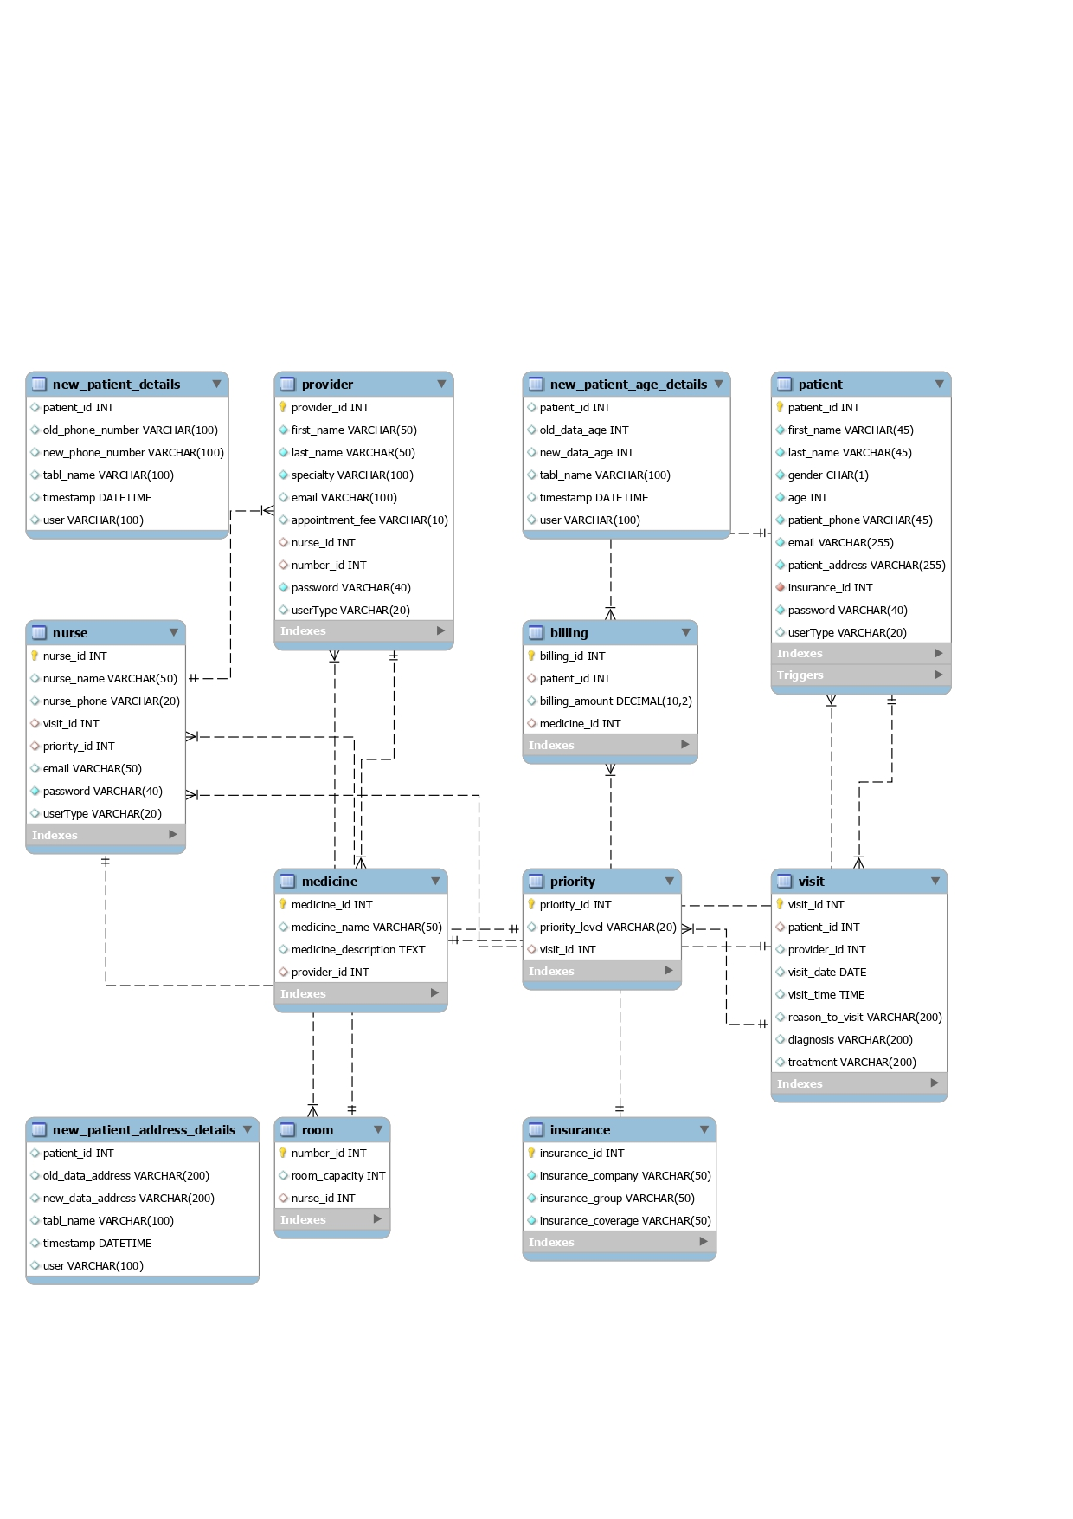

* “PROJECTONE” is the name of database created in the above ER Diagram, in total there are 9 tables in it which are connected to one another.
* The tables in the ER diagram contain columns that has attributes which hold data in the table of various types such as INT, DOUBLE, VARCHAR, etc. and each table has its primary key which uniquely identifies the table, it is represented by a yellow key icon. The red coloured diamond shaper icons in the diagram represent foreign keys associated with that table. For the table Patient, the primary key is the patient_id (represented by the yellow icon) and the insurance_id is the foreign key (represented by the red colour icon).
* The Insurance table has insurance_id as primary connected to the patient and does not have any foreign key.
* The Priority table has priority_id as the primary key and visit_id as a foreign key in it, connected with the nurse and visit tables.
* The Visit table has visit_id as the primary key and patient_id as a foreign key in it connected with the patient table, nurse and priority tables respectively.
* The Nurse table has nurse_id as the primary key, priority_id and visit_id as a foreign key which are visit, priority, provider and room tables.
* The Provider table has provider_id as the primary key, number_id and nurse_id as foreign keys in it. It is connected with the Nurse, Room, Medicine and Billing tables.
* The Medicine table has medicine_id as the primary key and provider_id as a foreign key in it and is connected with the provider and billing tables.
* The Billing table has billing_id as the primary key and medicine_id as a foreign key in it connected with the patient and medicine tables.

UML

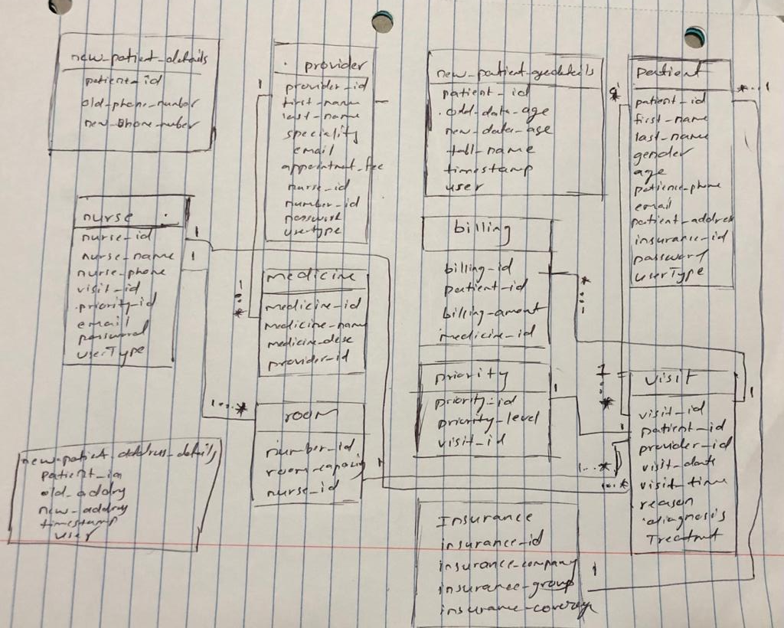

* **Patient** has a many-to-one relationship with **Insurance**.
* **Visit** has a many-to-one relationship with **patient**.
* **Visit** has a many-to-one relationship with **Provider**.
* **Priority** has a many-to-one relationship with **Visit**.
* **The nurse** has a many-to-one relationship with **Visit**.
* **Nurses have** a many-to-one relationship with **Priority**.
* **Room** has a many-to-one relationship with **Nurse**.
* **Provider** has a many-to-one relationship with **Nurse**.
* **The provider** has a many-to-one relationship with **Room**.
* **Medicine** has a many-to-one relationship with **Provider**.

**PROOF OF BCNF**

The database satisfies the 3NF condition. All the 1NF, 2NF and 3NF should be satisfied. This database is in1NF because all column names are unique, and values are stored in the column of same domain which satisfies 2NF as there is no partial Dependency in it.

A relation is in BCNF if X is super key for every functional dependency (FD) X,Y in given relation.

For example, consider relation R (A, B, C)

A -> BC,

B->A

* Insurance: insurance_id → insurance_company, insurance_group, insurance_coverage
* Patient: patient_id → first_name, last_name, gender, age, patient_phone, patient_email, patient_address, insurance_id
* Visit: visit_id → patient_id, provider_id, visit_date, visit_time, reason_to_visit, diagnosis, treatment
* Priority: priority_id → priority_level, visit_id
* Nurse: nurse_id → nurse_name, nurse_phone, visit_id, priority_id
* Room: number_id → room_capacity, nurse_id
* Provider: provider_id → first_name, last_name, specialty, email_address, appointment_fee, nurse_id, number_id
* Medicine: medicine_id → medicine_name, medicine_description, provider_id
* Billing: billing_id → patient_id, billing_amount, medicine_id

From the above functional dependencies, we can see that each table has at least one candidate key. Therefore, every table in the schema is in BCNF.

**TABLE INFORMATION: Tables and Column Attributes:**

**Insurance table:**

* insurance_id
* insurance_company
* insurance_group
* insurance_coverage

**Patient table:**

* patient_id
* first_name
* last_name
* gender
* age
* patient_phone
* email
* patient_address
* insurance_id
* password
* userType

**Visit table:**

* visit_id
* patient_id
* provider_id
* visit_date
* visit_time
* reason_to_visit
* diagnosis
* treatment

**Priority table:**

* priority_id
* priority_level
* visit_id

**Nurse table:**

* nurse_id
* nurse_name
* email
* nurse_phone

* visit_id
* priority_id
* password
* userType

**Room table:**

* number_id
* room_capacity
* nurse_id

**Provider table:**

* provider_id
* first_name
* last_name
* specialty
* email
* appointment_fee
* nurse_id
* number_id
* password
* userType

**Medicine table:**

* medicine_id
* medicine_name
* medicine_description
* provider_id

**Billing table:**

* billing_id
* patient_id
* billing_amount
* medicine_id

**new_patient_address_details**

|  |
| --- |
| * patient_id |
| * old_data_address |
| * new_data_address |
| * tabl_name |
| * timestamp |
| * user |

**new_patient_age_details**

|  |
| --- |
| * patient_id |
| * old_data_age |
| * new_data_age |
| * tabl_name |
| * timestamp |
| * user |

**new_patient _details**

|  |
| --- |
| * patient_id |
| * old_phone_number |
| * new_phone_number |
| * tabl_name |
| * timestamp |
| * user |

**Updated portion in the database from Project 1:**

Added password, userType and emails in the provider, patient, nurse tables as a plan to access the database with 3 kinds of users.   
  
Additionally added the Audit tables and along with them the triggers.

Application Programming Interface (API) Implementation:

**Stored Procedures:**

**CreatePatient Stored procedure**

drop procedure if exists CreatePatient;

DELIMITER //

CREATE PROCEDURE CreatePatient(

IN p_patient_id INT,

IN p_first_name VARCHAR(45),

IN p_last_name VARCHAR(45),

IN p_gender CHAR(1),

IN p_age INT,

IN p_patient_phone VARCHAR(45),

IN p_email VARCHAR(255),

IN p_patient_address VARCHAR(255),

IN p_insurance_id INT,

IN p_password VARCHAR(255),

IN p_userType varchar(45)

)

BEGIN

DECLARE existing_count INT;

-- Check if the patient ID already exists

SELECT COUNT(*) INTO existing_count

FROM Patient

WHERE patient_id = p_patient_id;

IF existing_count > 0 THEN

SIGNAL SQLSTATE '45000'

SET MESSAGE_TEXT = 'Patient ID already exists.';

ELSE

-- Insert the new patient record

INSERT INTO Patient (

patient_id,

first_name,

last_name,

gender,

age,

patient_phone,

email,

patient_address,

insurance_id,

password,

userType

) VALUES (

p_patient_id,

p_first_name,

p_last_name,

p_gender,

p_age,

p_patient_phone,

p_email,

p_patient_address,

p_insurance_id,

p_password,

p_userType

);

END IF;

END //

DELIMITER ;

#CALL CreatePatient(90, 'Johndd', 'Dode', 'M', 30, '123-456-7890', 'johddn.doe@example.com', '123 Main St', 1, 'passworddemo','patient');

select * from patient;

This Stored procedure is used to insert new patients into the PATIENT table by taking the inputs from the web page (SignIn.html) where the user of type patient sign into the application by providing his details.

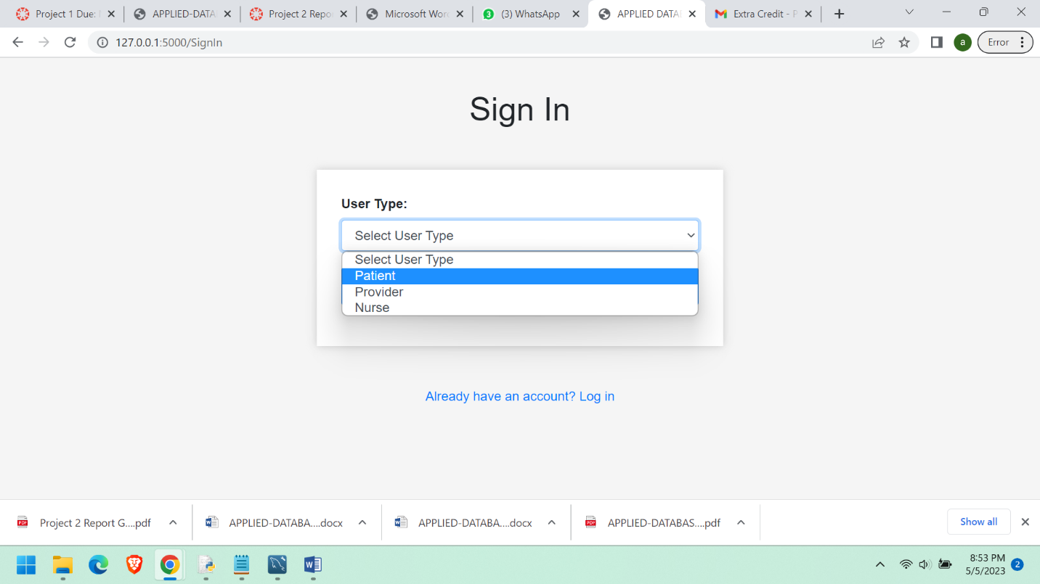

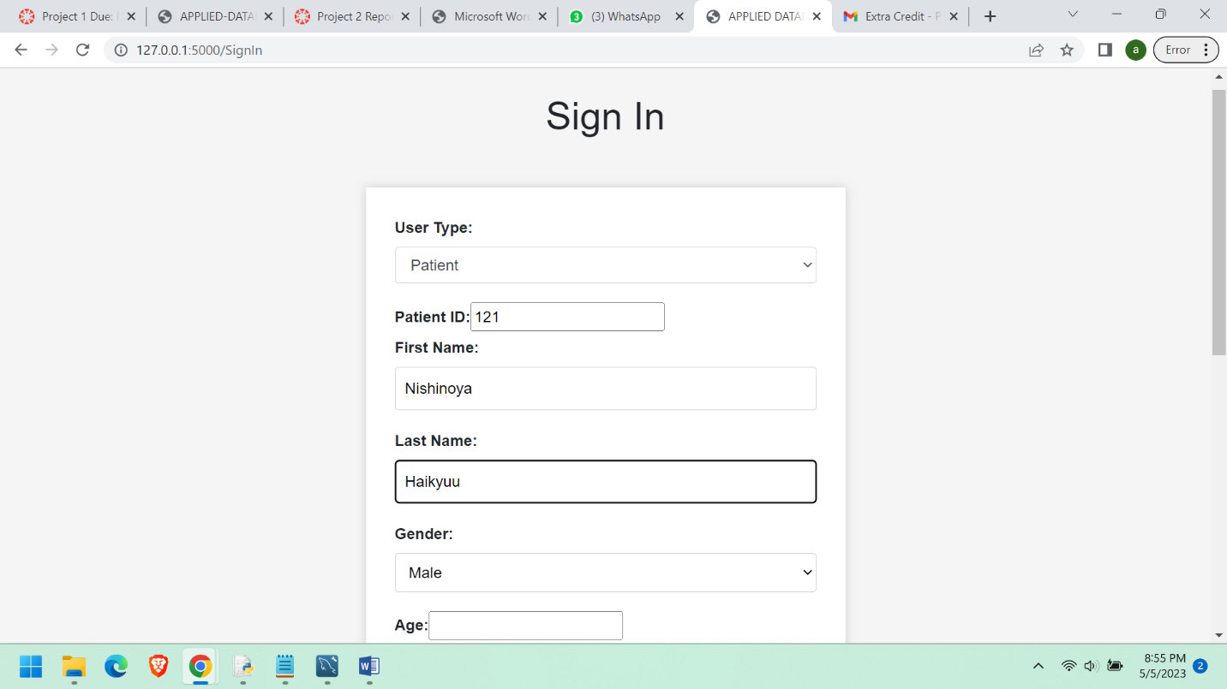

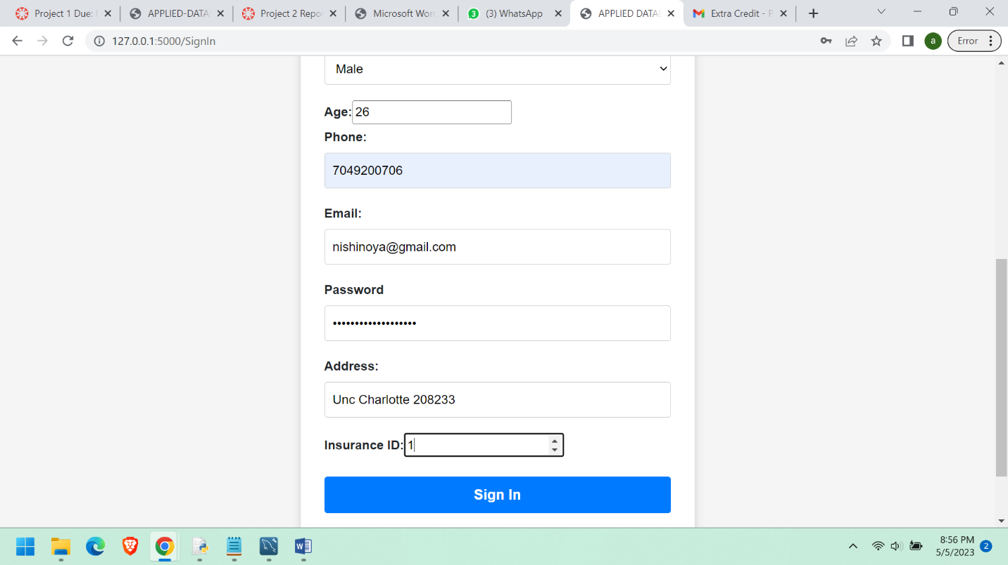

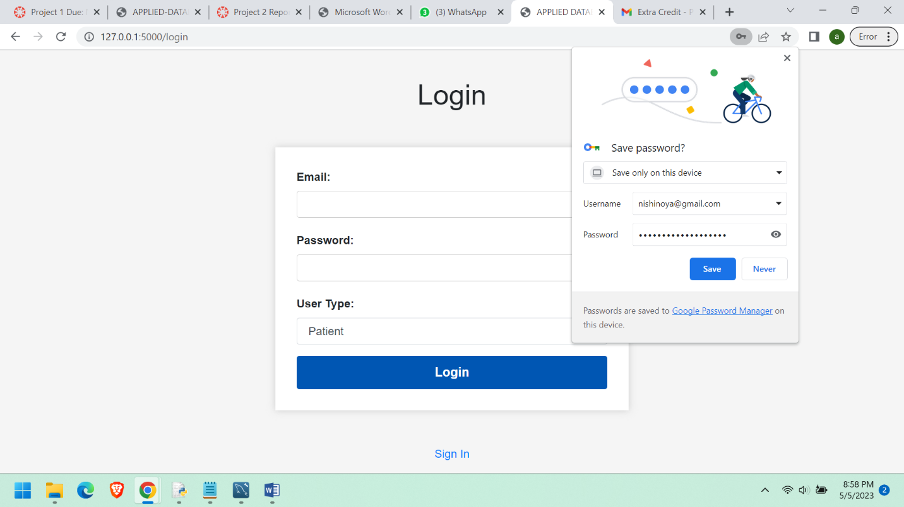

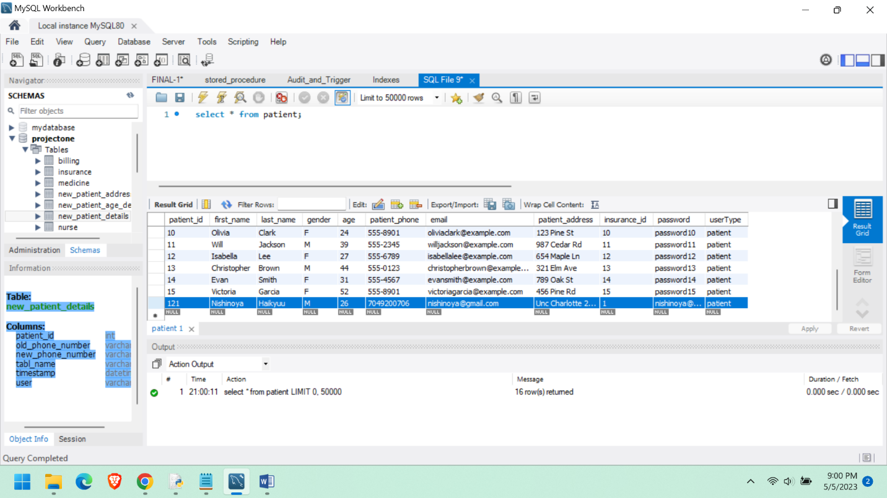

In the above screen shot we can see that the new user is being added to the patient table once the user clicks on signIn.

**CREATE_PROVIDER STORED PROCEDURE**

drop procedure if exists createProvider;

DELIMITER //

CREATE PROCEDURE CreateProvider(

IN p_provider_id INT,

IN p_first_name VARCHAR(50),

IN p_last_name VARCHAR(50),

IN p_specialty VARCHAR(100),

IN p_email VARCHAR(255),

IN p_appointment_fee VARCHAR(10),

IN p_nurse_id INT,

IN p_number_id INT,

IN p_password VARCHAR(50),

IN p_userType VARCHAR(20)

)

BEGIN

DECLARE existing_count INT;

-- Check if the provider ID already exists

SELECT COUNT(*) INTO existing_count

FROM Provider

WHERE provider_id = p_provider_id;

IF existing_count > 0 THEN

SIGNAL SQLSTATE '45000'

SET MESSAGE_TEXT = 'Provider ID already exists.';

ELSE

-- Insert the new provider record

INSERT INTO Provider (

provider_id,

first_name,

last_name,

specialty,

email,

appointment_fee,

nurse_id,

number_id,

password,

userType

) VALUES (

p_provider_id,

p_first_name,

p_last_name,

p_specialty,

p_email,

p_appointment_fee,

p_nurse_id,

p_number_id,

p_password,

p_userType

);

END IF;

END //

DELIMITER ;

#CALL CreateProvider(100, 'Erwin', 'Smith', 'Cardiology', 'erwin.smith@example.com', '100', 1, 1, 'password', 'provider');

select * from Provider;

This Stored procedure is used to insert new provider into the PROVIDER table by taking the inputs from the web page (SignIn.html) where the user of type provider sign into the application by providing his details.

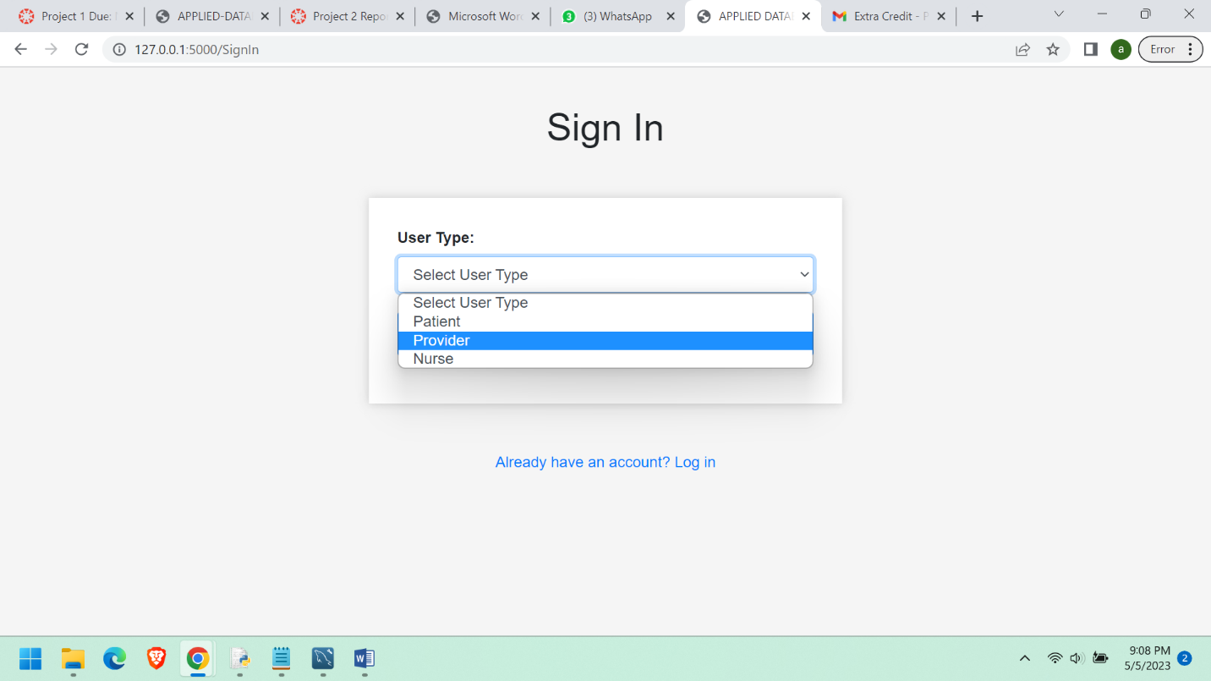

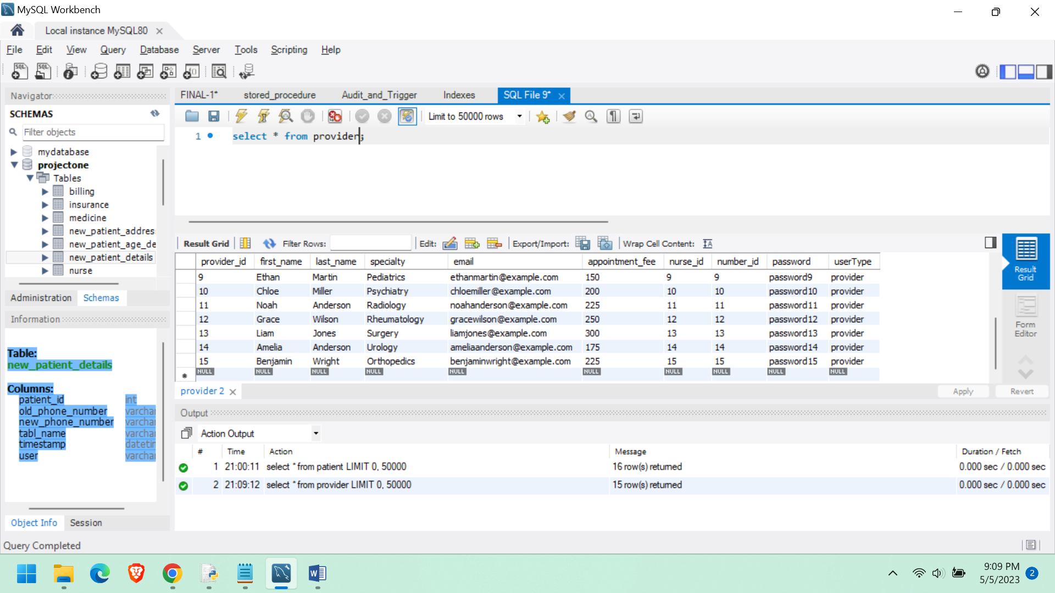

Before the user sign in into the application his details are not there in the the database.

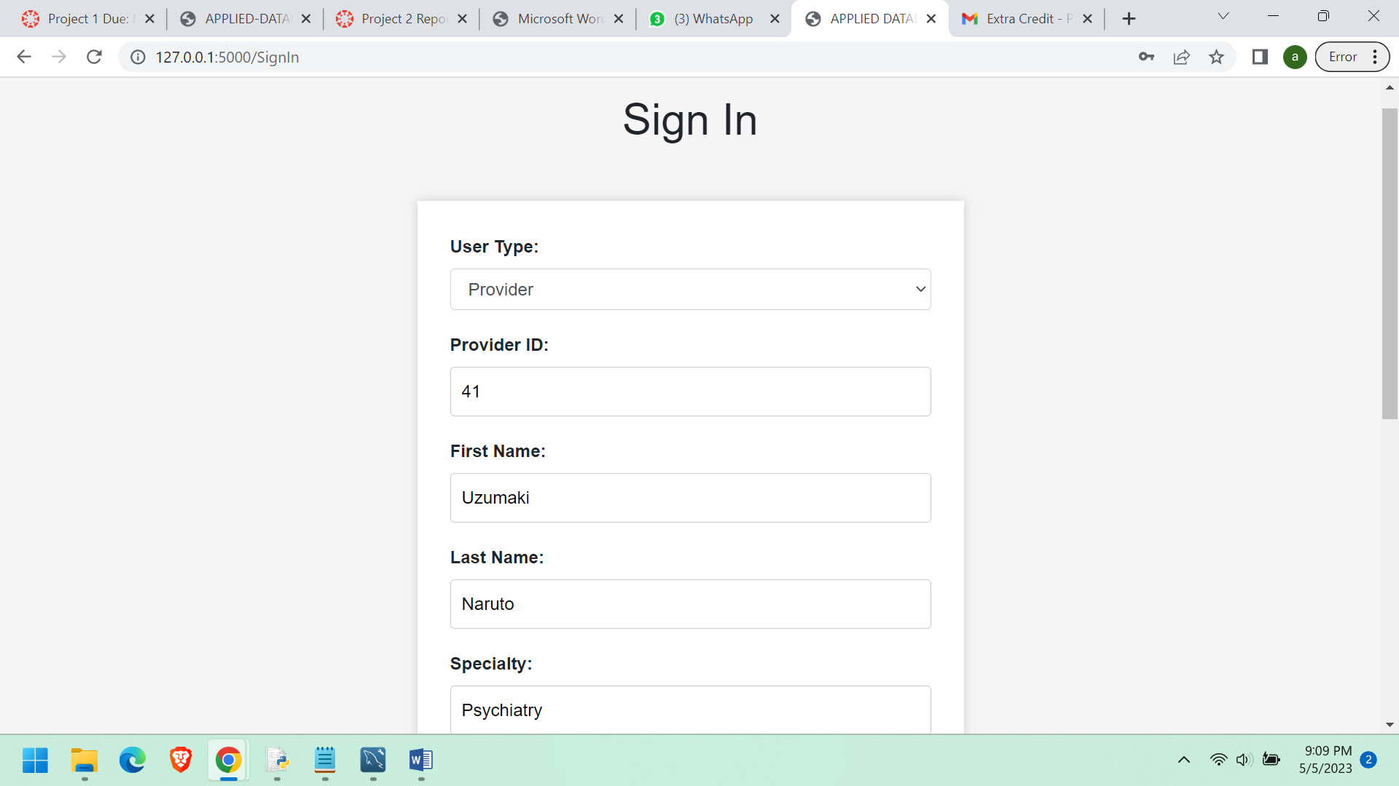

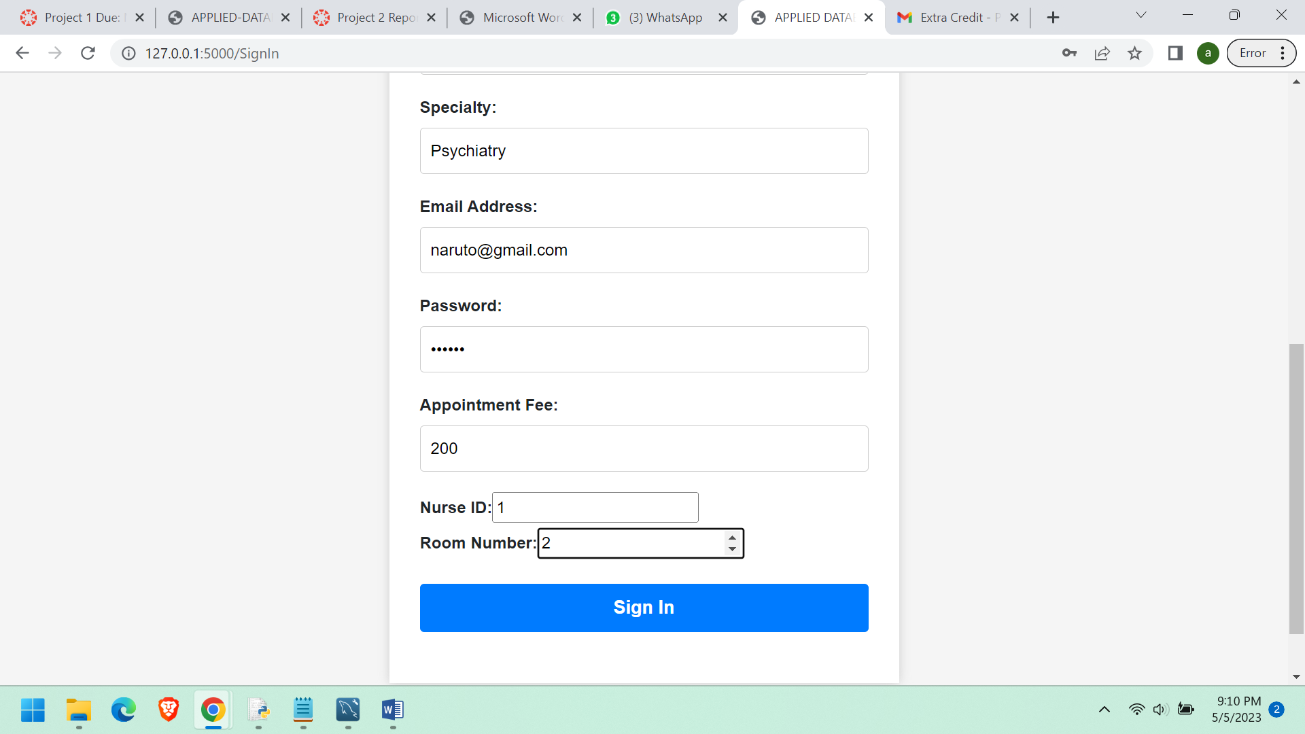

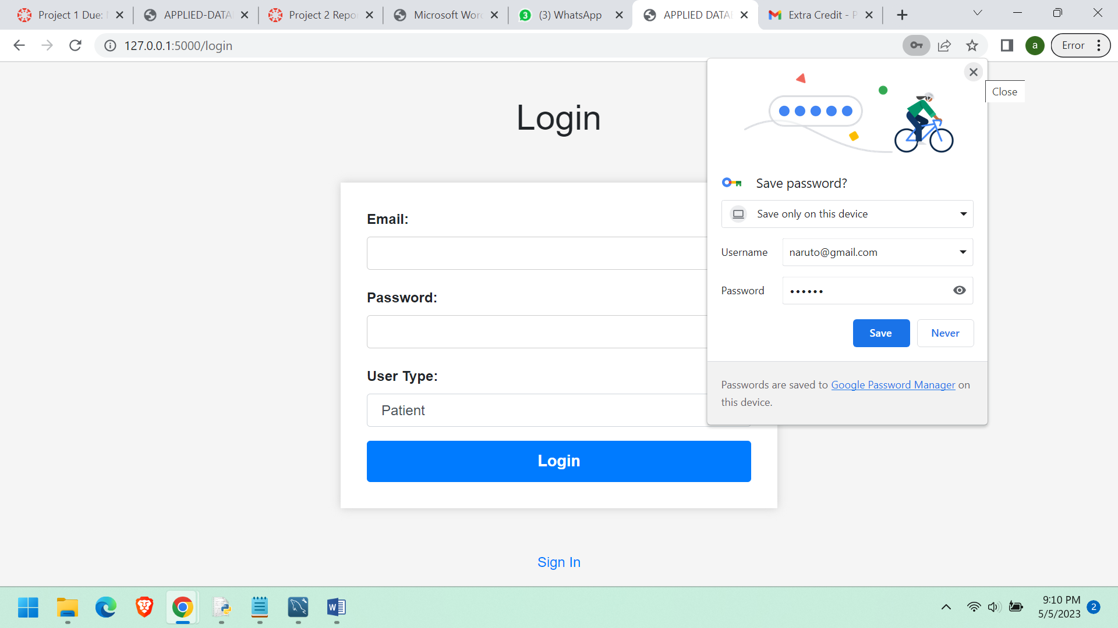

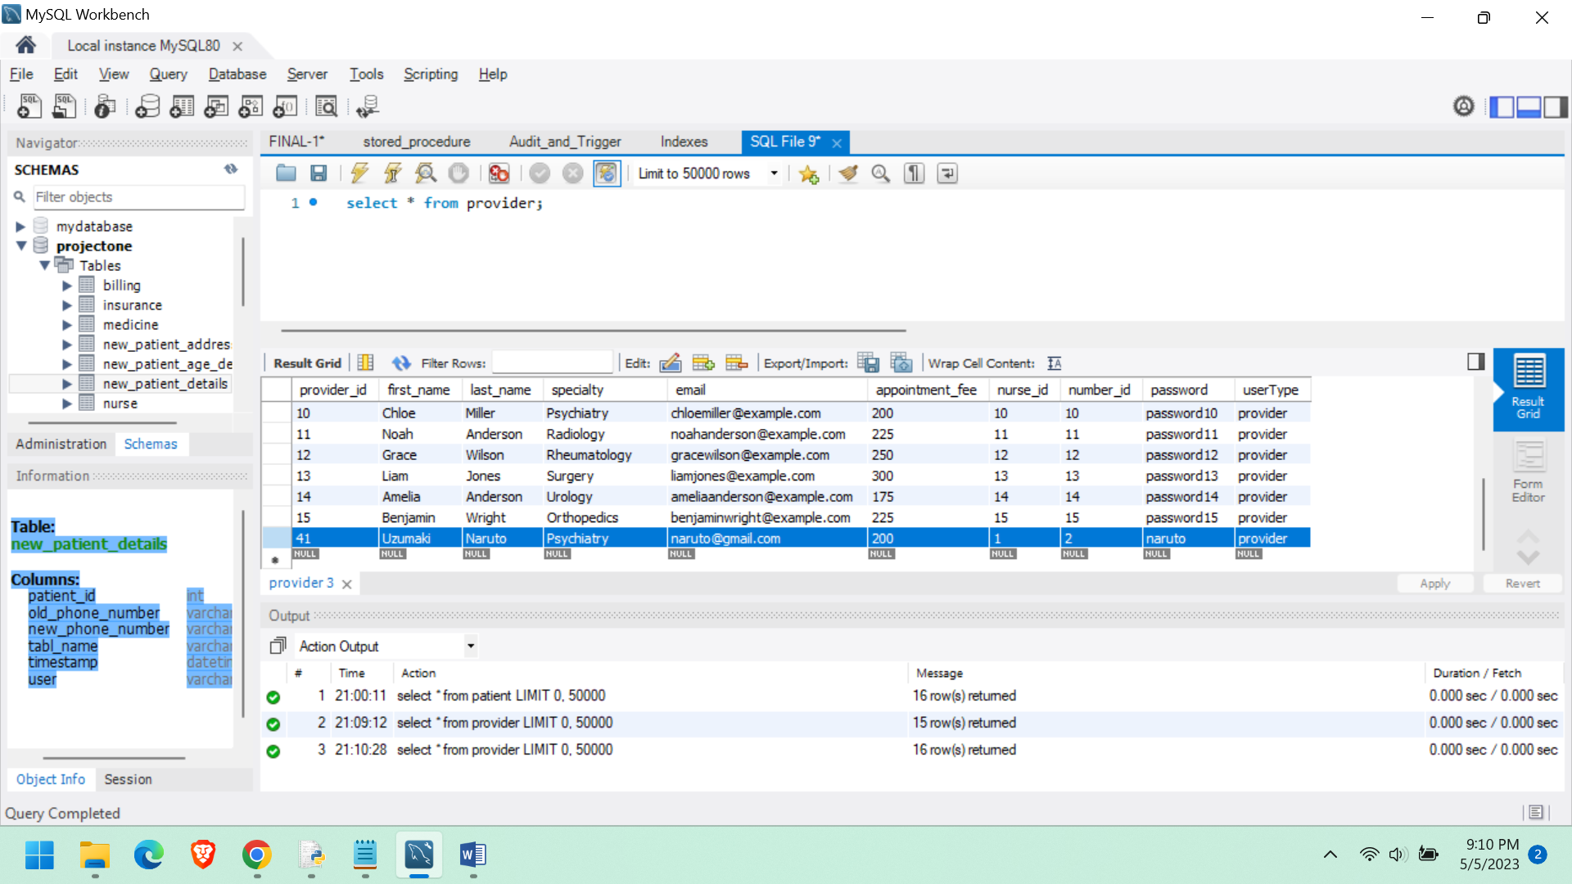

After signing up we can see that the user is added successfully.

**CreateNurse Stored Procedure**

drop procedure if exists CreateNurse;

DELIMITER //

CREATE PROCEDURE CreateNurse(

IN p_nurse_id INT,

IN p_nurse_name VARCHAR(50),

IN p_nurse_phone VARCHAR(20),

IN p_visit_id INT,

IN p_priority_id INT,

IN p_email VARCHAR(50),

IN p_password VARCHAR(50),

IN p_userType VARCHAR(20)

)

BEGIN

DECLARE existing_count INT;

-- Check if the nurse ID already exists

SELECT COUNT(*) INTO existing_count

FROM Nurse

WHERE nurse_id = p_nurse_id;

IF existing_count > 0 THEN

SIGNAL SQLSTATE '45000'

SET MESSAGE_TEXT = 'Nurse ID already exists.';

ELSE

-- Insert the new nurse record

INSERT INTO Nurse (

nurse_id,

nurse_name,

nurse_phone,

visit_id,

priority_id,

email,

password,

userType

) VALUES (

p_nurse_id,

p_nurse_name,

p_nurse_phone,

p_visit_id,

p_priority_id,

p_email,

p_password,

p_userType

);

END IF;

END //

DELIMITER ;

#CALL CreateNurse(123, 'John Bha', '123-456-7890', 1, 1, 'john.doe@example.com', 'passwordjha', 'nurse');

select * from nurse;

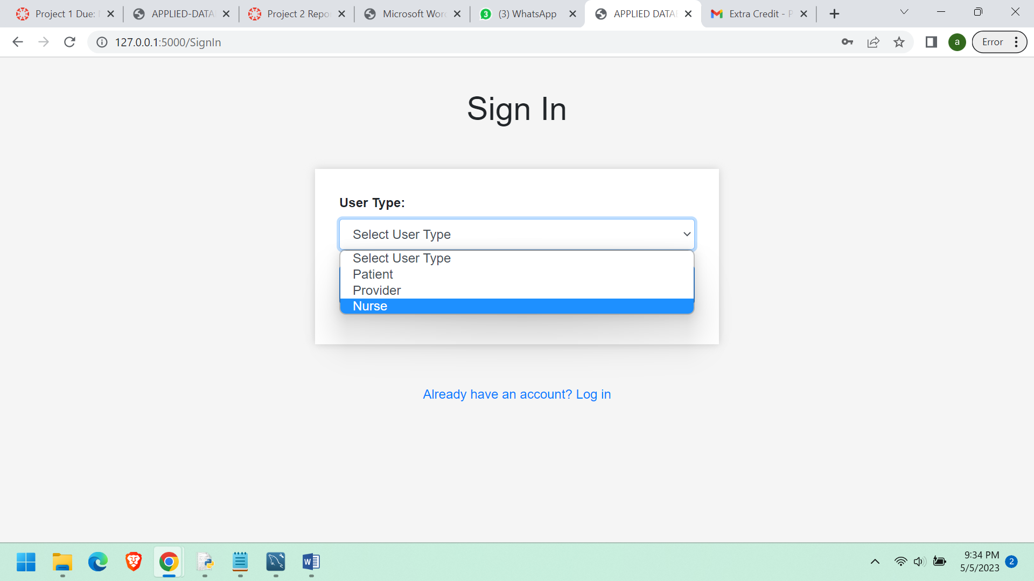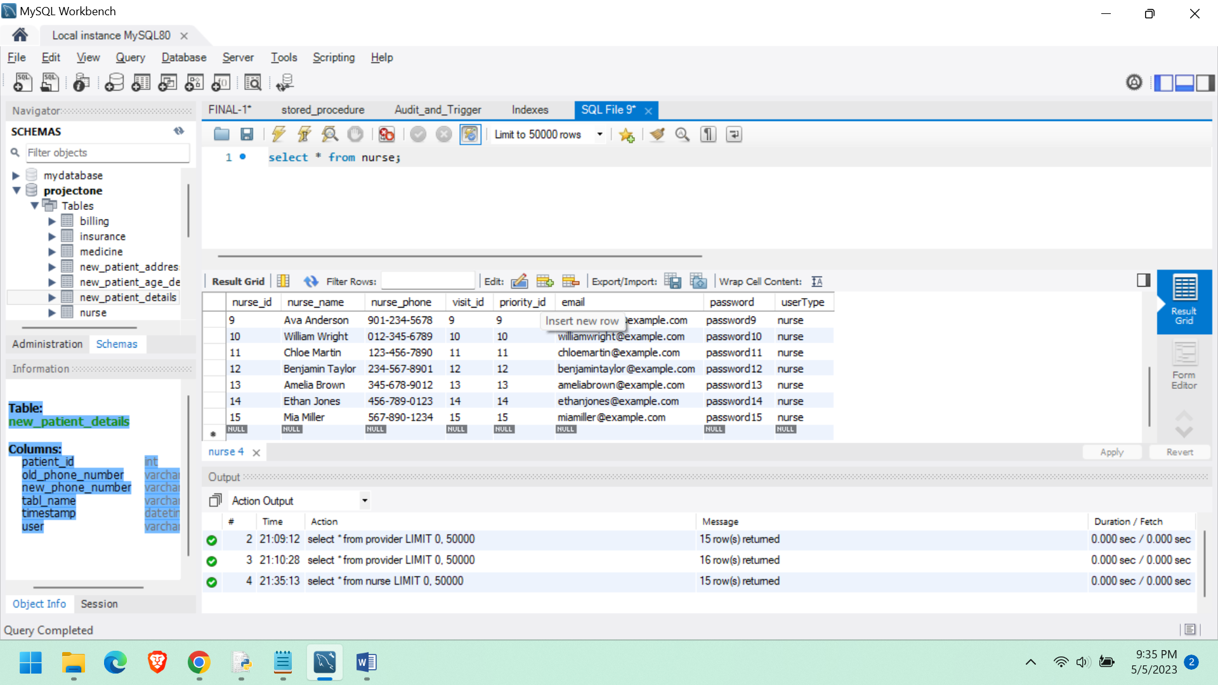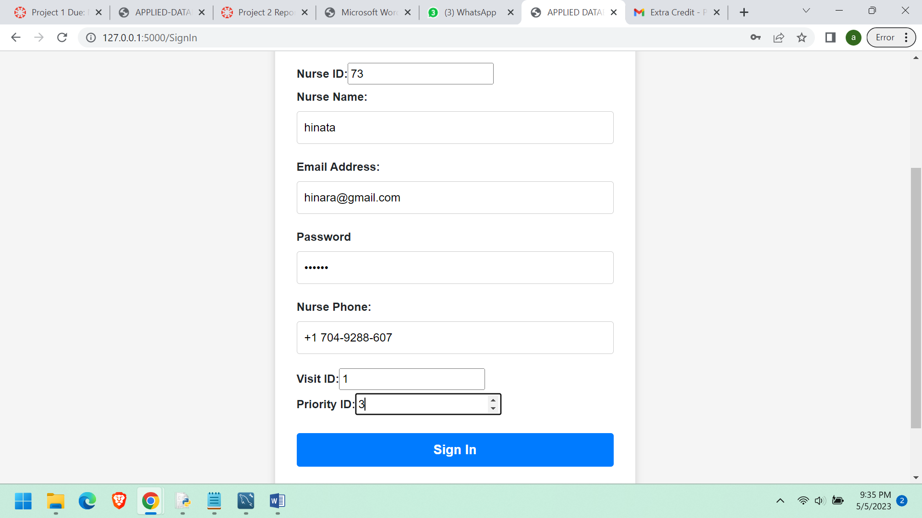

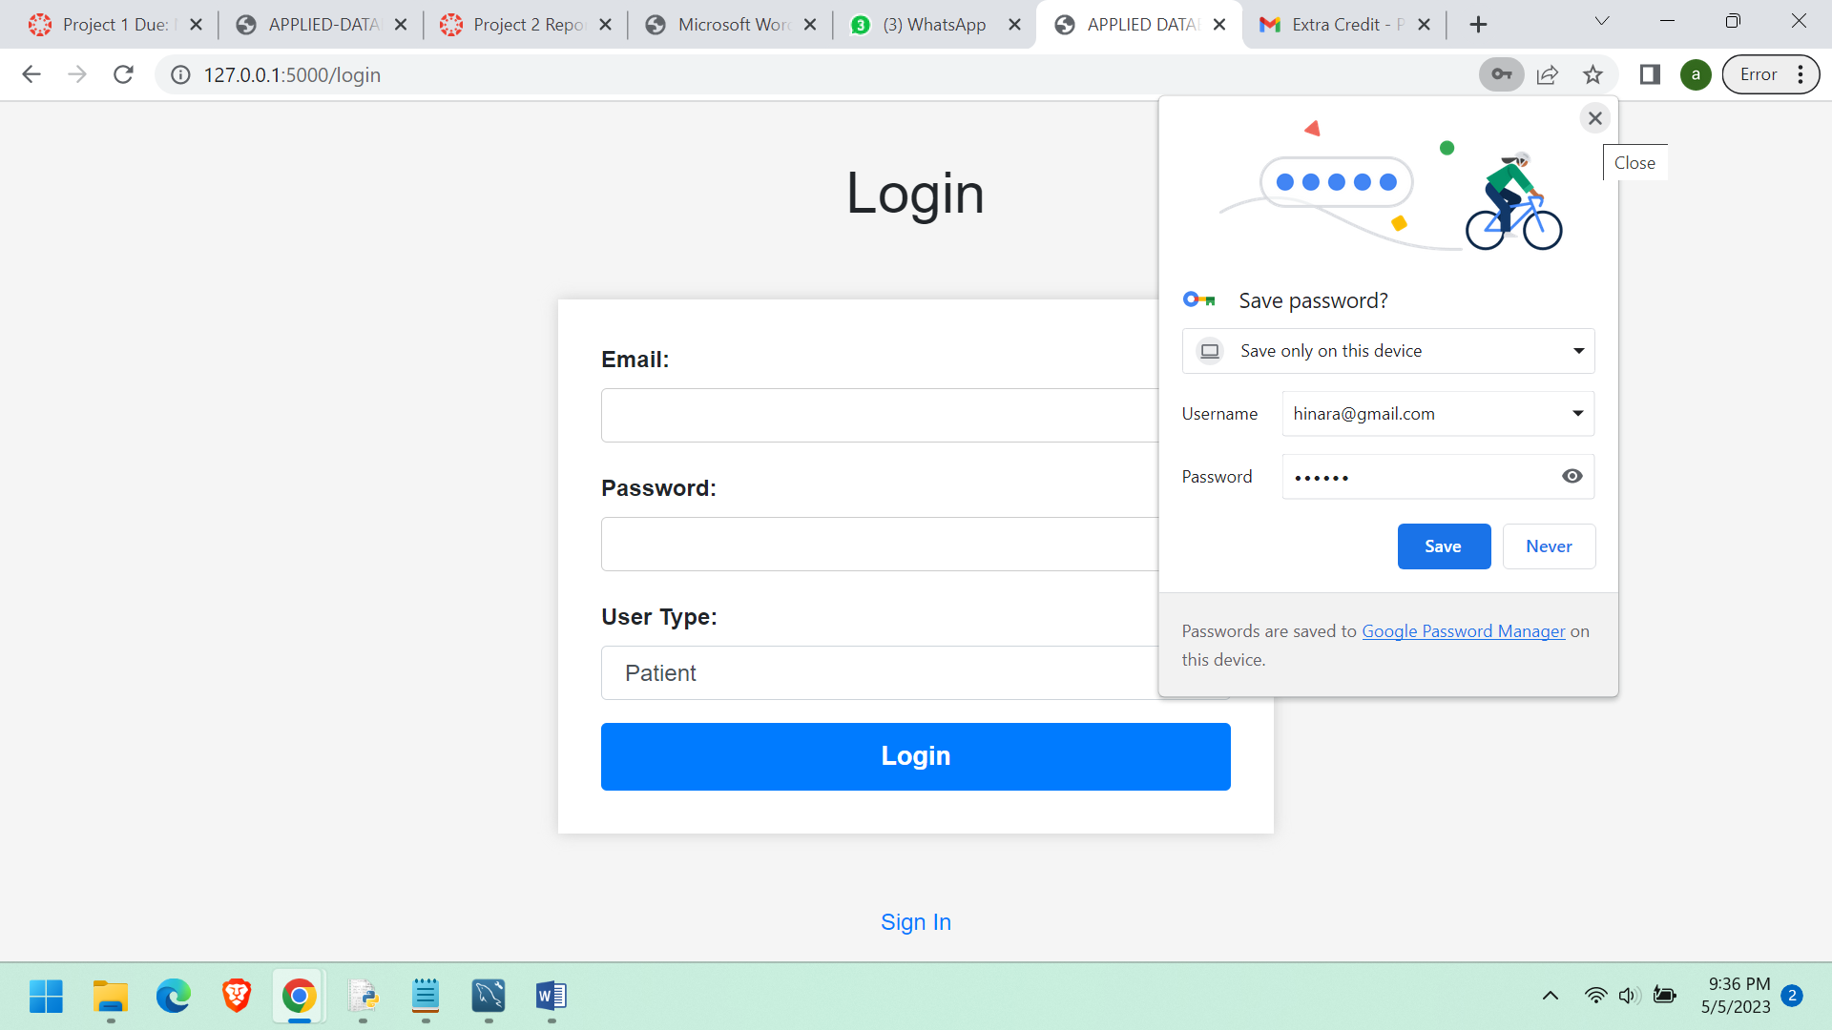

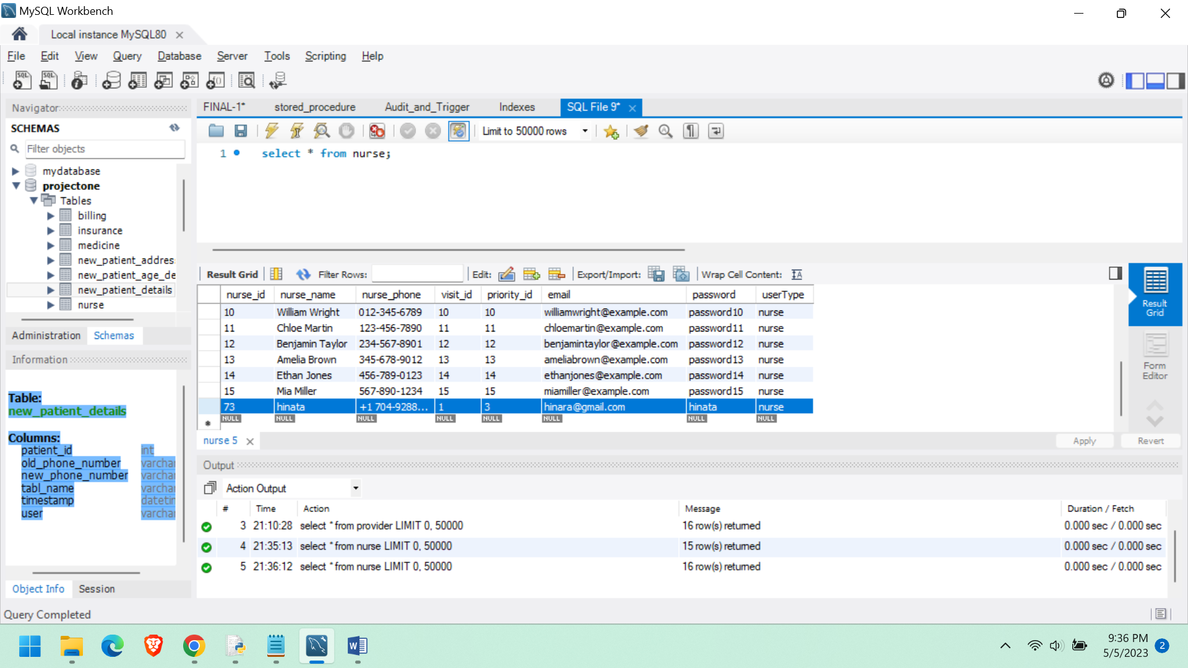

**CalculateBill Stored Procedure**

drop procedure if exists CalculateBill;

DELIMITER $$

CREATE PROCEDURE CalculateBill(IN patientID INT)

BEGIN

DECLARE totalAmount DECIMAL(10, 2);

SELECT SUM(billing_amount) INTO totalAmount

FROM billing

WHERE patient_id = patientID;

This Stored procedure will get the results from the biling table when we provide that particular patient id.

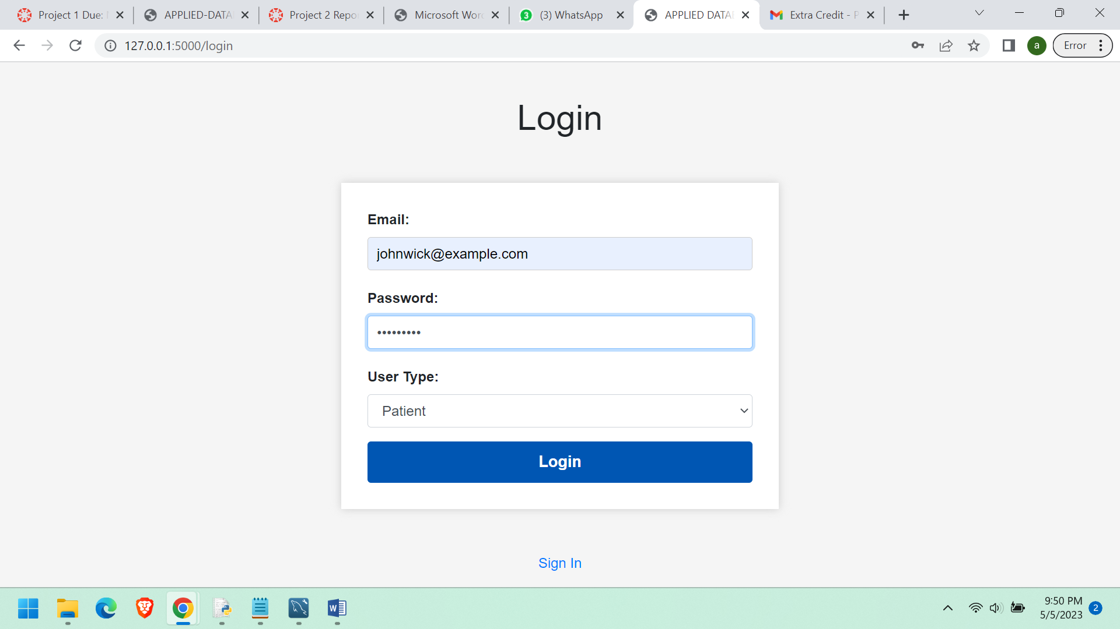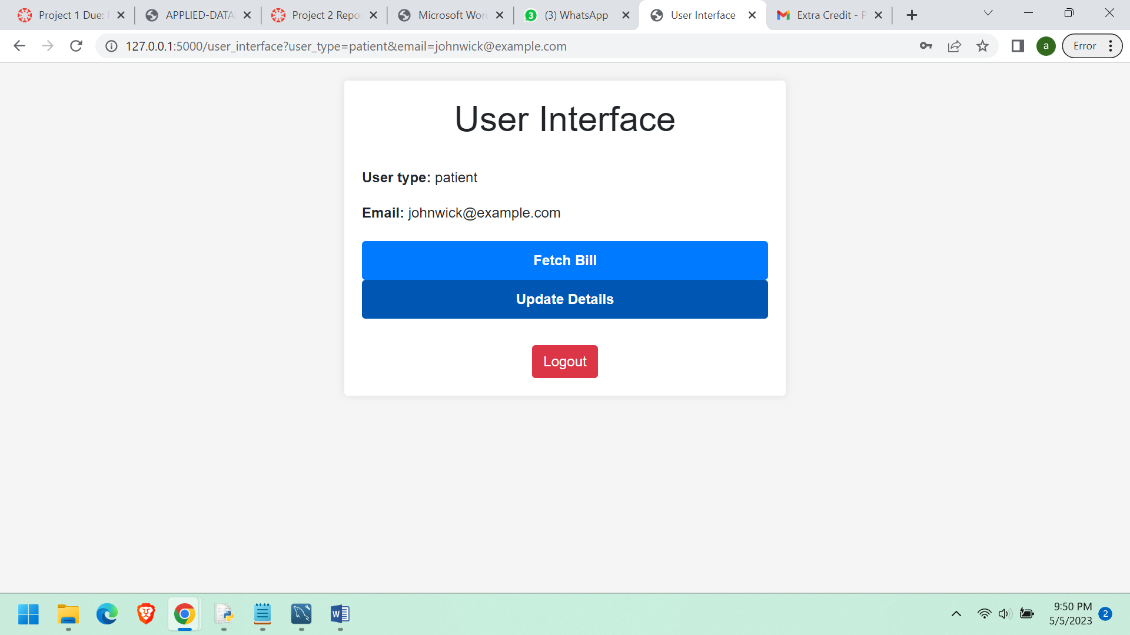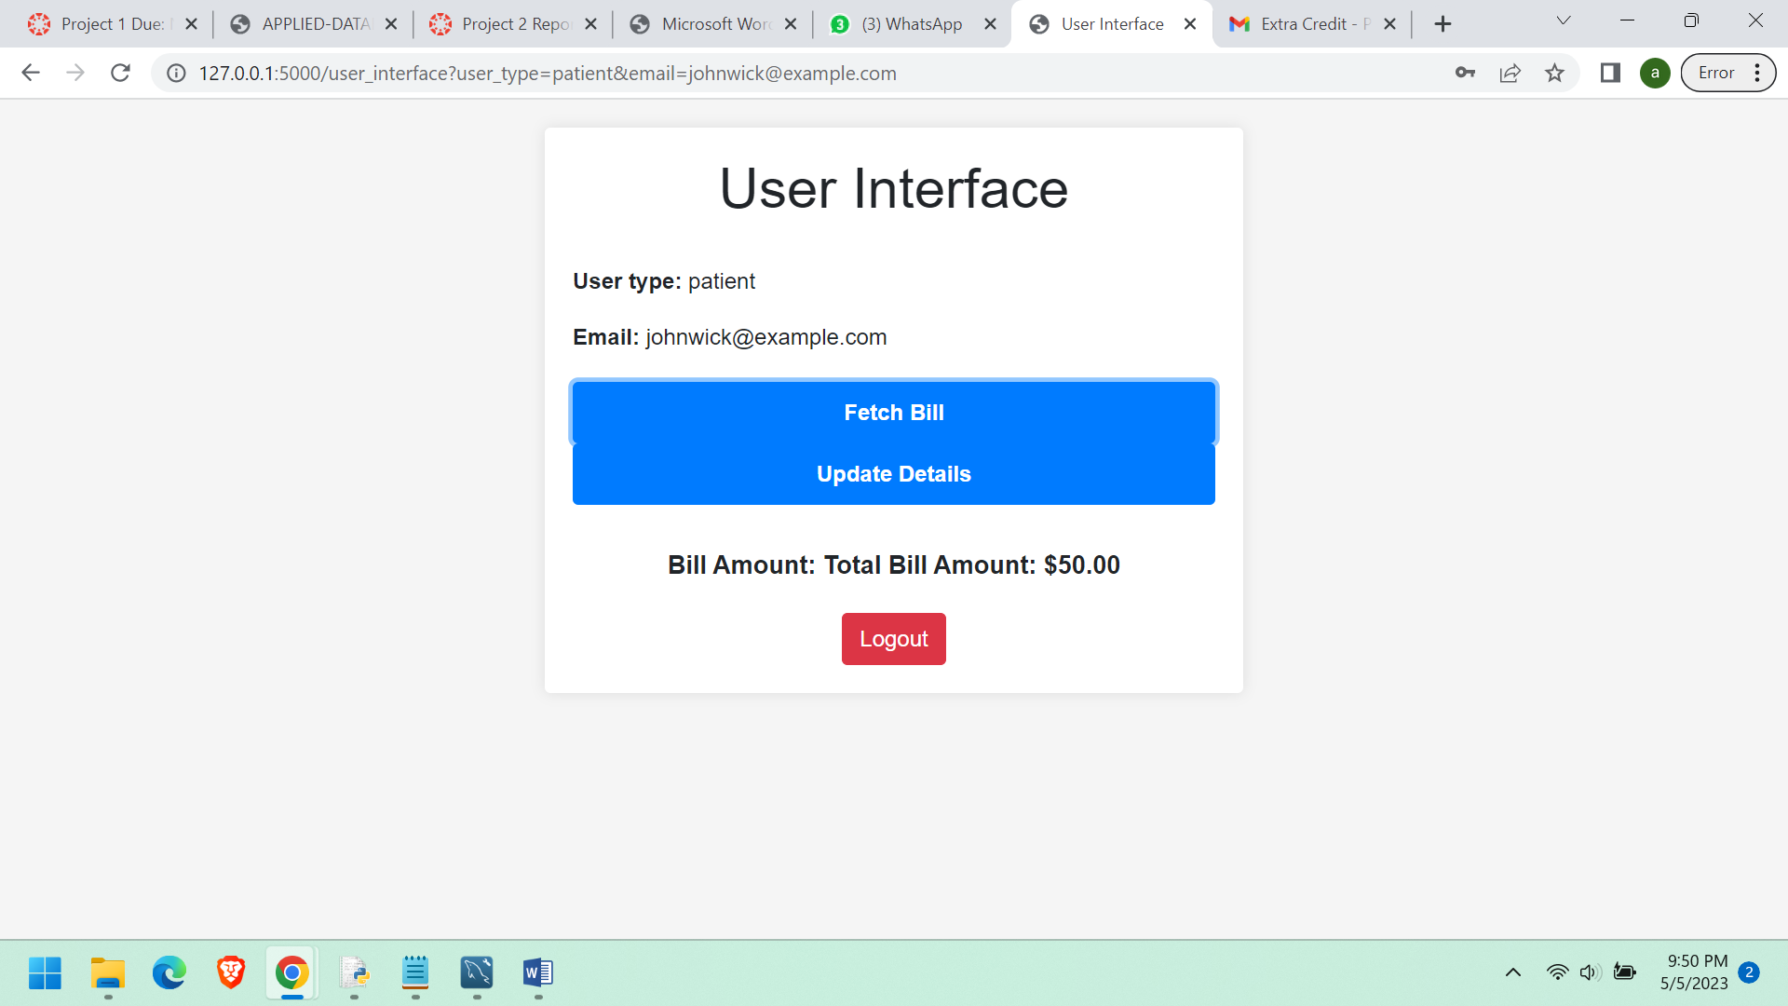

**Now lets take a random patient and get his billing amount.**

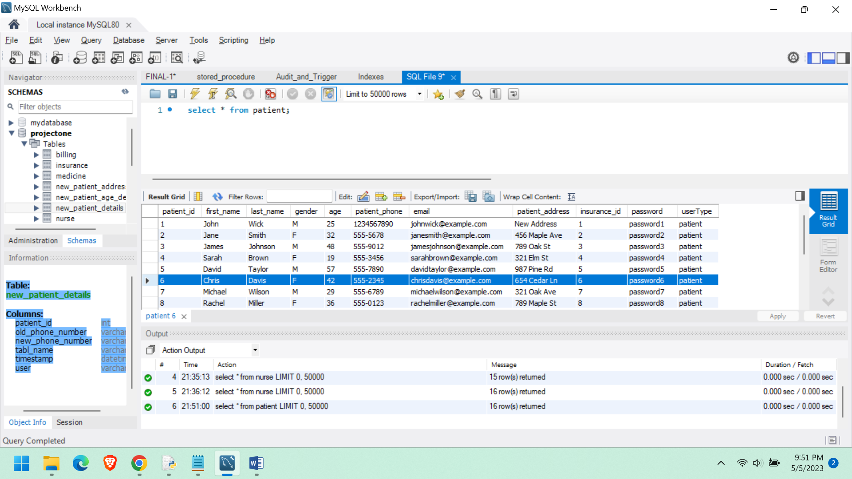

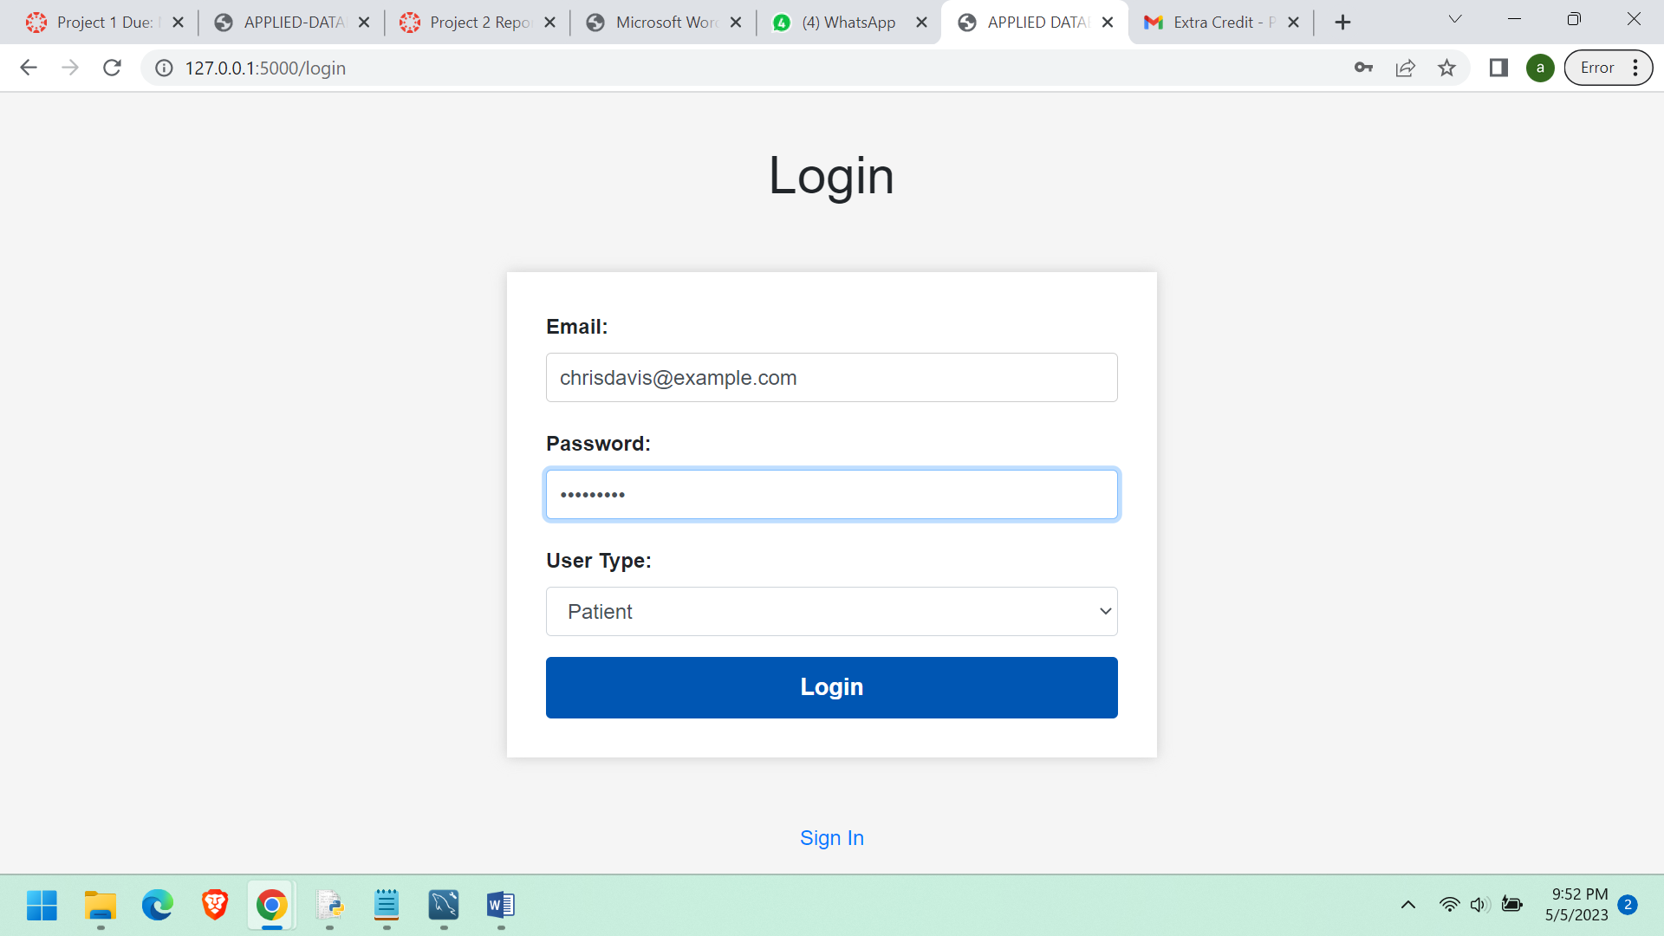

**We can see that the user bill amount is being displayed in the below**

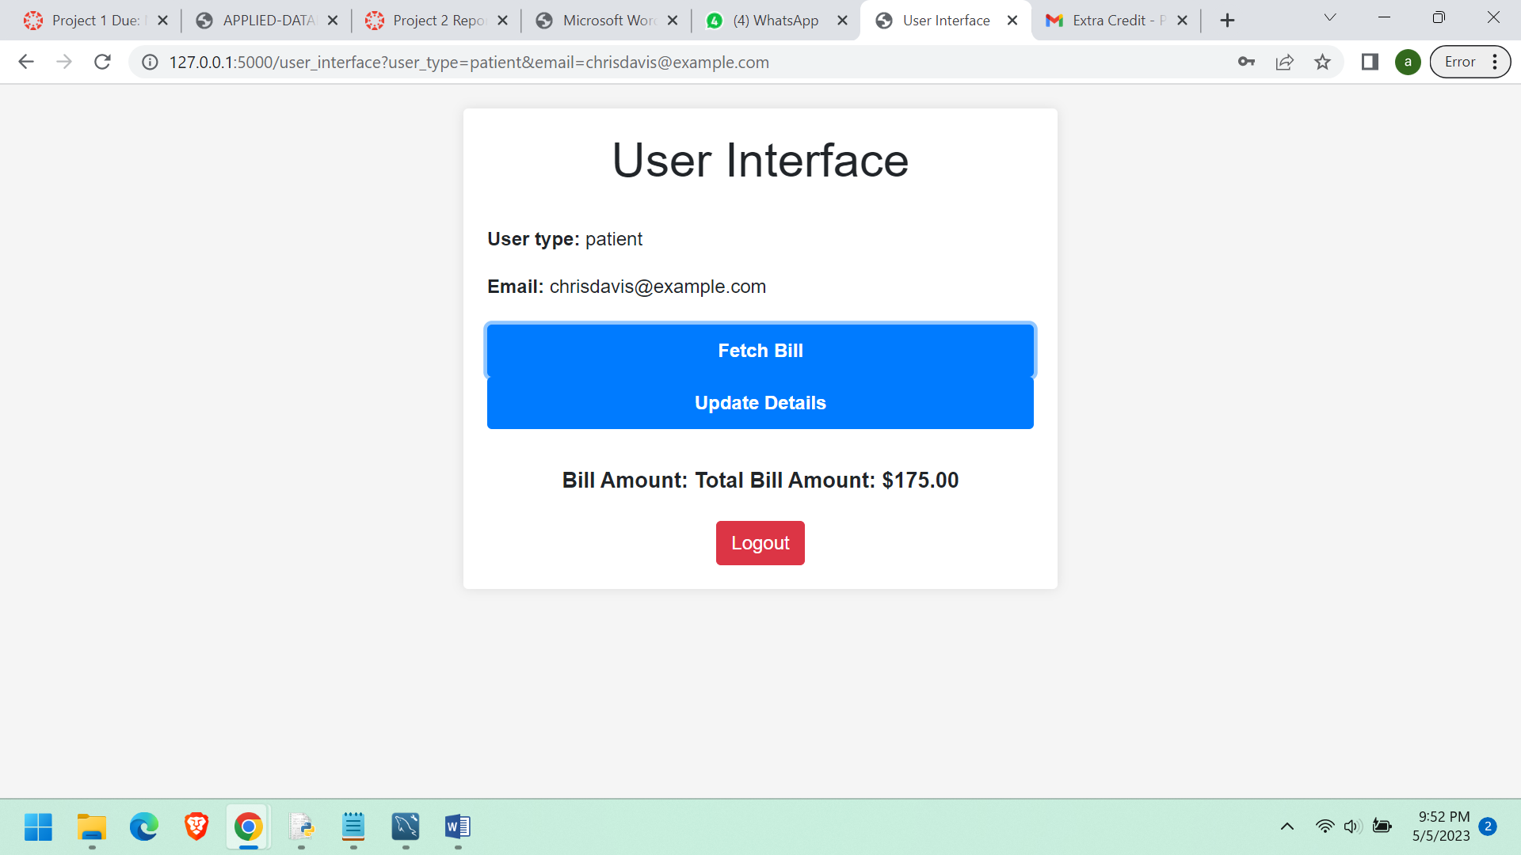

**GetVisitsByDateRange Stored procedure.**

drop procedure if exists GetVisitsByDateRange;

DELIMITER $$

CREATE PROCEDURE GetVisitsByDateRange(IN startDate DATE, IN endDate DATE, IN providerId INT)

BEGIN

SELECT CONCAT('Debug: startDate=', startDate) AS Debug;

SELECT CONCAT('Debug: endDate=', endDate) AS Debug;

SELECT CONCAT('Debug: providerId=', providerId) AS Debug;

SELECT *

FROM Visit

WHERE visit_date BETWEEN startDate AND endDate

AND provider_id = providerId;

END$$

DELIMITER ;

CALL GetVisitsByDateRange('2022-01-01', '2023-12-31', 1);  
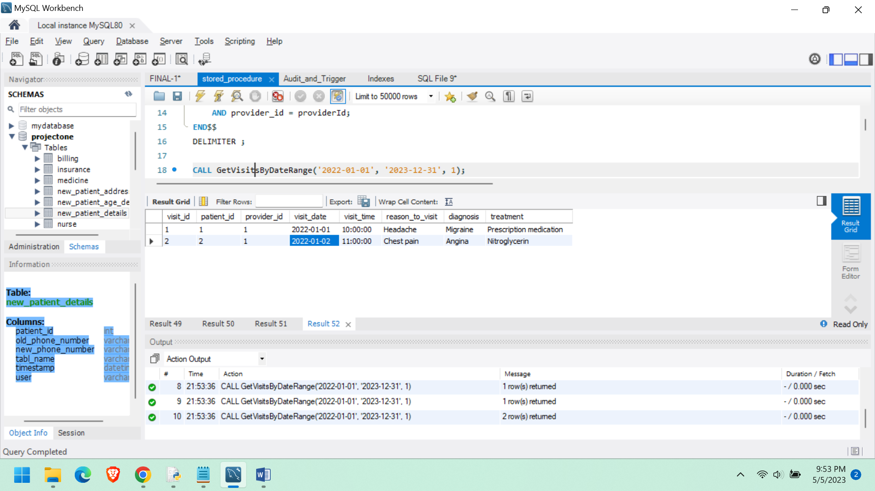

This stored procedure will get the visits of patients passed on the provider id.

**UpdatePatientDetails Stored procedure**

drop procedure if exists UpdatePatientDetails;

DELIMITER //

CREATE PROCEDURE UpdatePatientDetails(

IN patientID INT,

IN newPhone VARCHAR(45),

IN newAge INT,

IN newAddress VARCHAR(255)

)

BEGIN

UPDATE Patient

SET

patient_phone = newPhone,

age = newAge,

patient_address = newAddress

WHERE patient_id = patientID;

SELECT 'Patient details updated successfully' AS message;

END//

DELIMITER ;

CALL UpdatePatientDetails(1, '1234567890', 25, 'New Address')

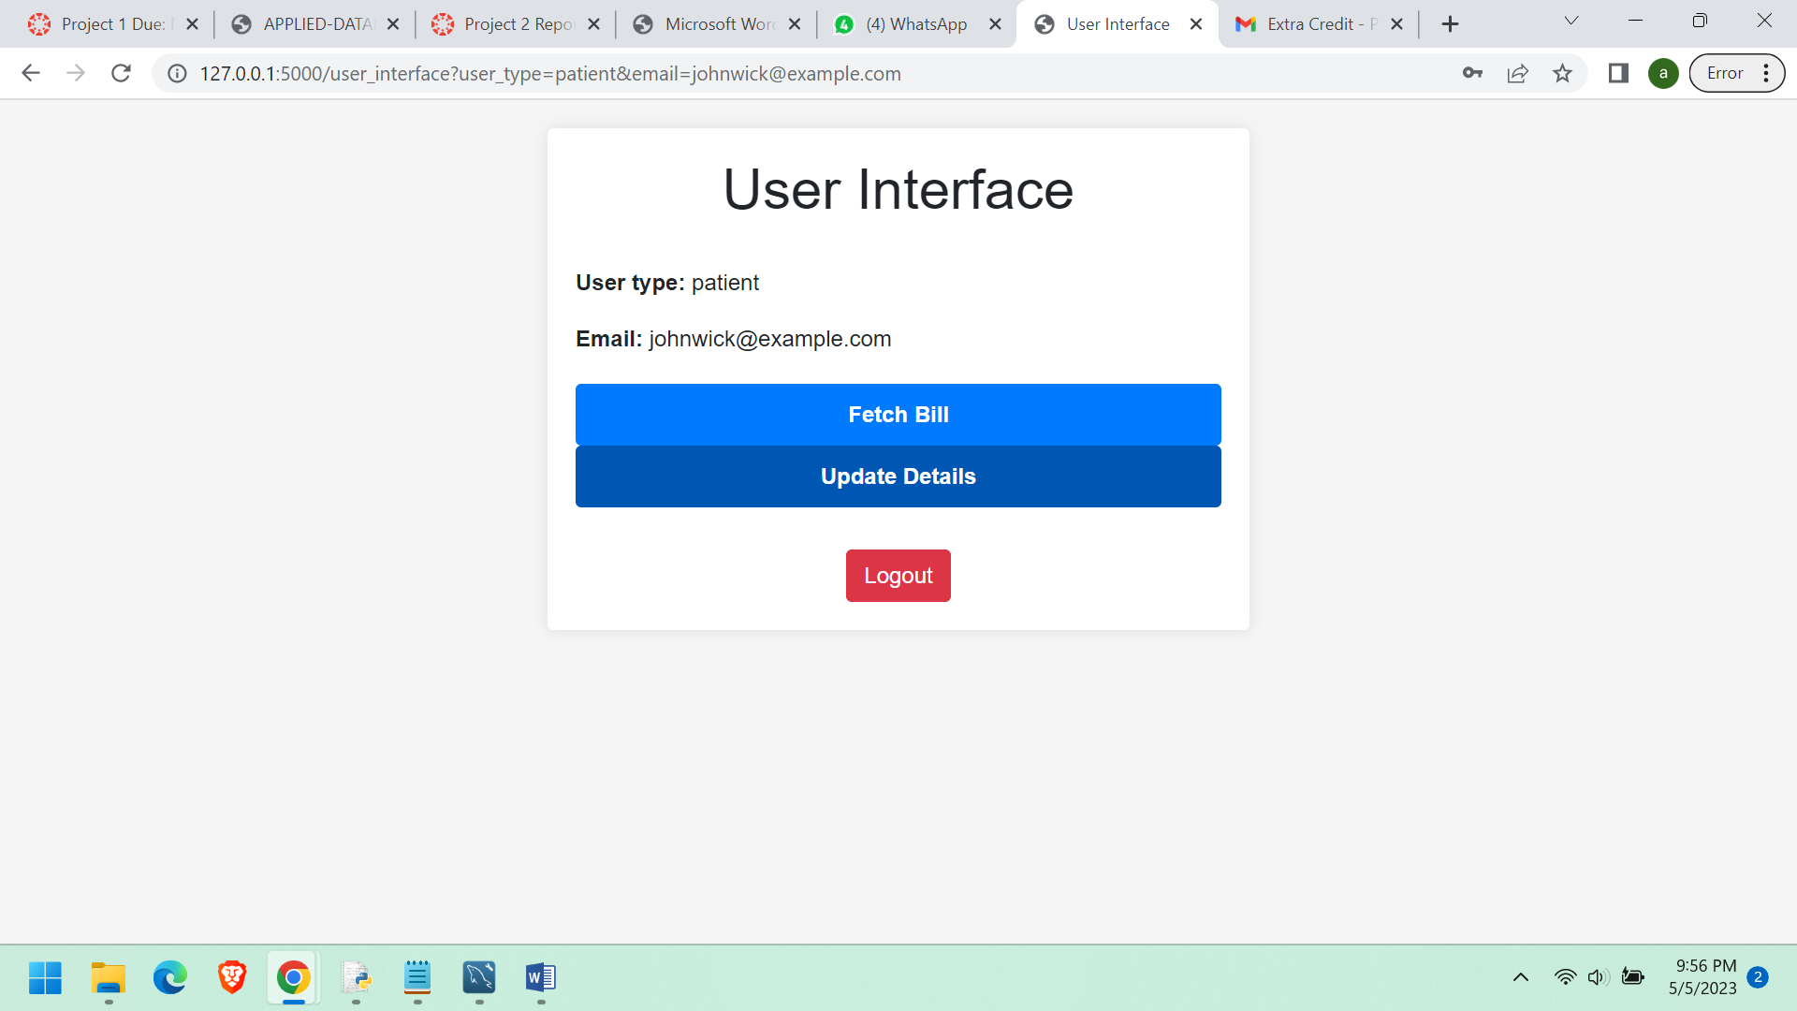

**On clicking on the UpdateDetails button it routes to this page.**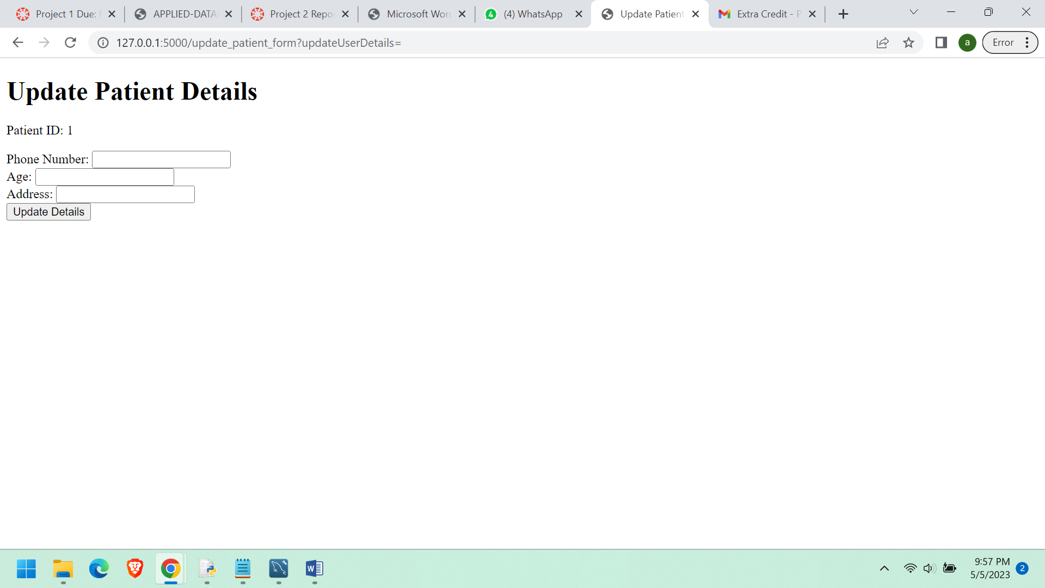

**We can see that when the button Update details is clicked the above details gets updated in the database.**

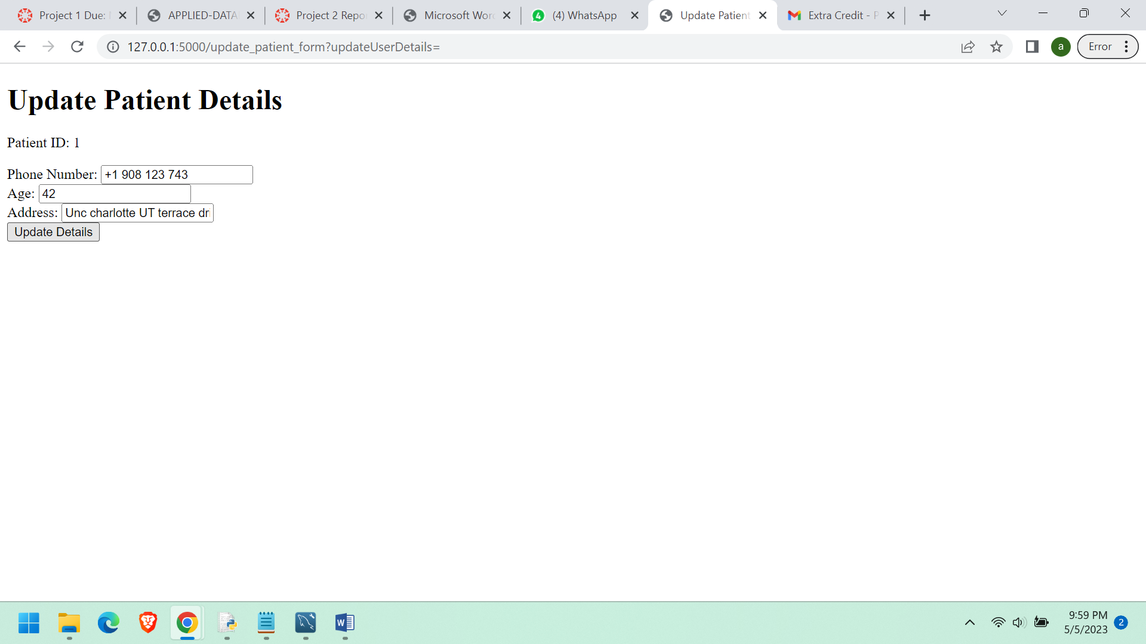

**We can see that the above details are updated in the database.**

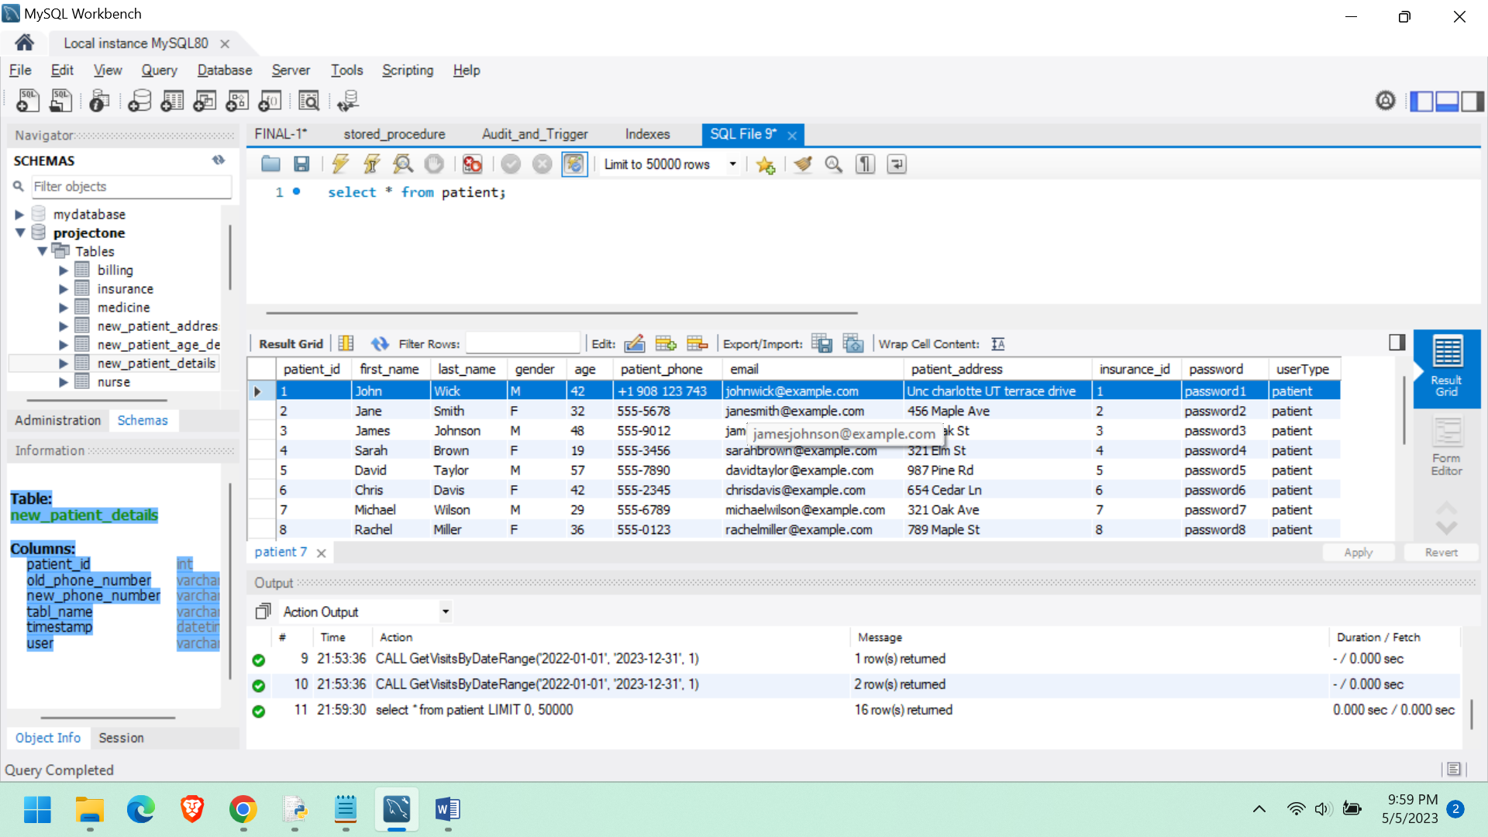

**User Authentication and ROLE BASED ACCESS CONTROL:**

The system has three types of users: **patient, provider, and nurse**. Each user type has a unique set of access privileges, which are determined by the user's role in the healthcare system. When a user attempts to sign in, their credentials are verified against the user database. If the credentials are valid, the user is granted access to the system and their access privileges are determined by their user type.

The list of users and their access privileges is stored in the MySQL database and is managed by the application administrator. Each user has a username and a password, which are used to authenticate their identity and grant access to the system.

The user's credentials are verified against the user database using SQL queries. The user's type is determined based on the value of the 'user_type' variable, which is obtained from the login form. If the user's credentials are valid, they are granted access to the system, and their access privileges are determined by their user type. The access privileges for each user type are stored in the MySQL database and are managed by the application administrator.

I have implemented the code in such a way that there are few restrictions to users based on the user_type in which they can access data or update data.

Suppose a user of type “patient” can get the bill amount and update his details but where as the provider can generate all patients bills and also he can update each and every patient details, he is like an admin. But where as the nurse can only check the patient bills but cannot update the user details.

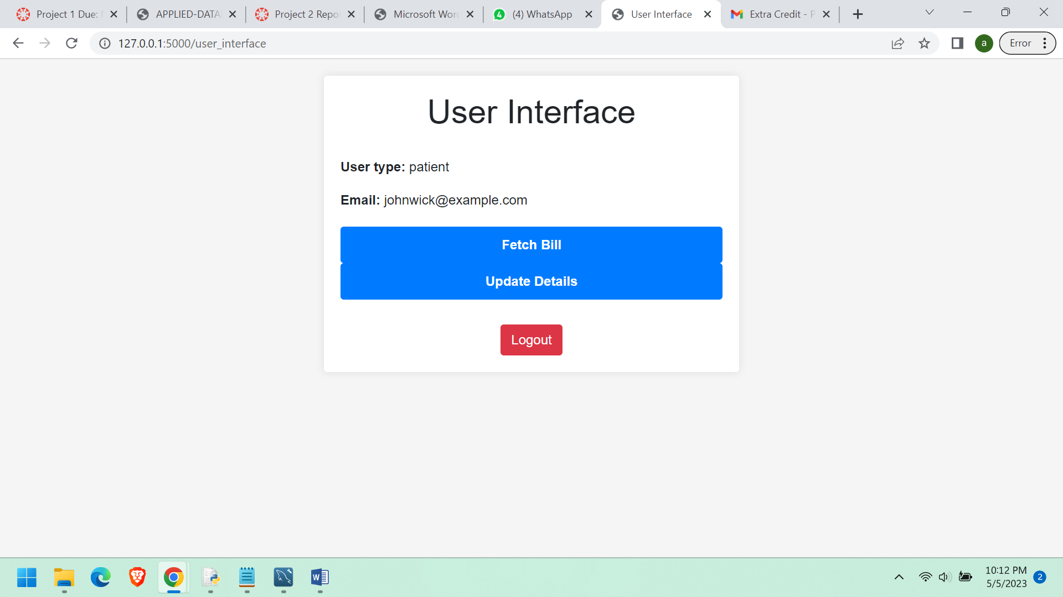

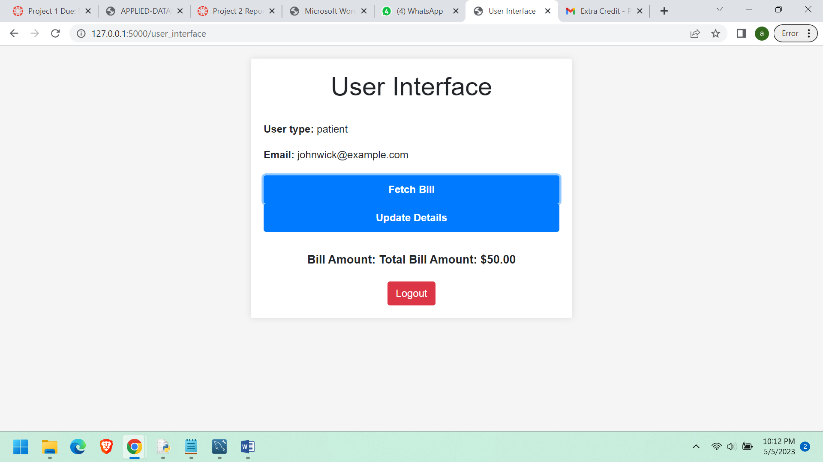

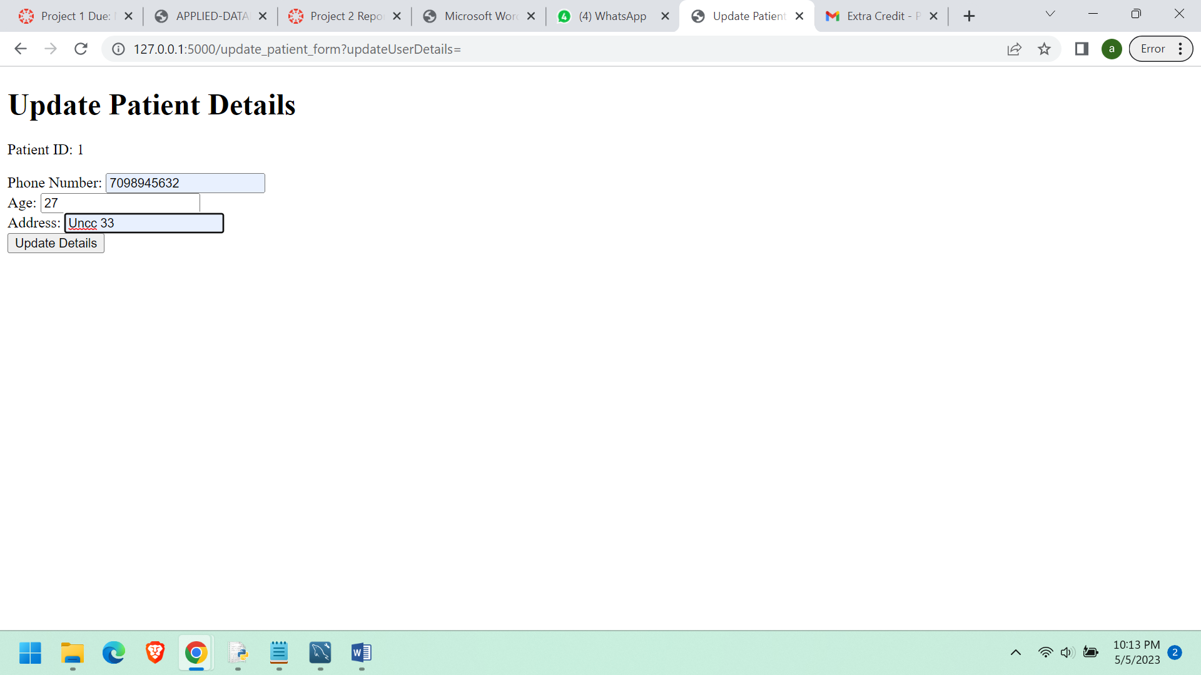

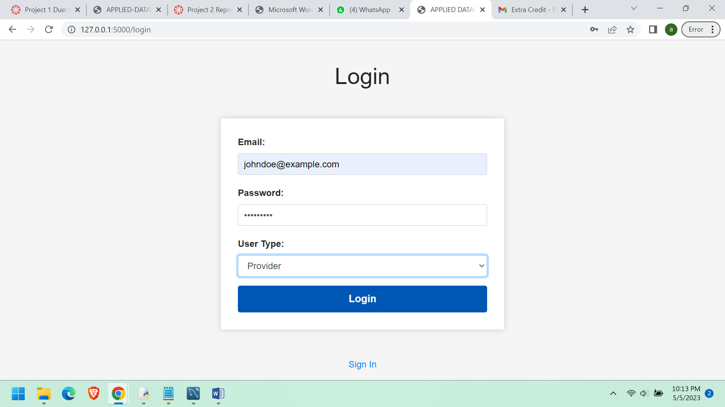

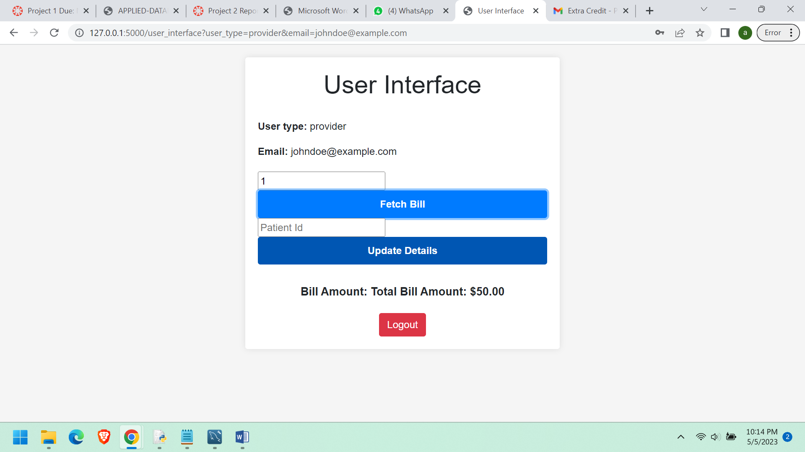

**Provider can generate multiple patients bills.**

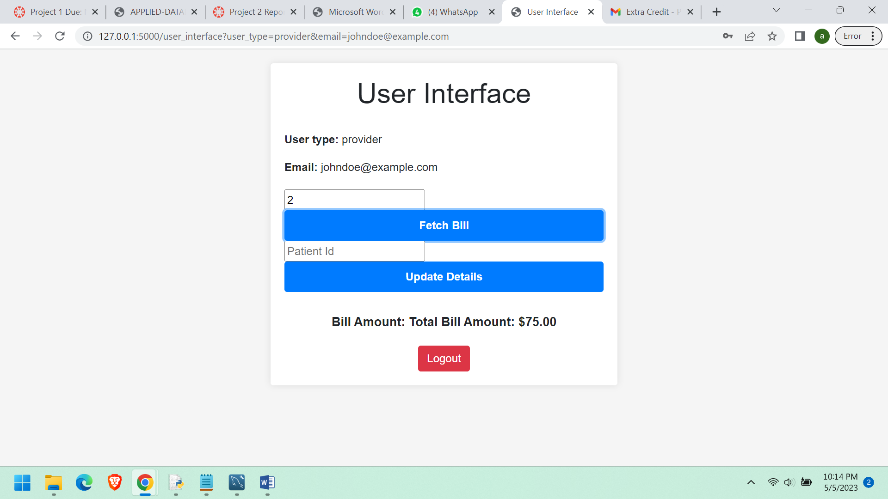

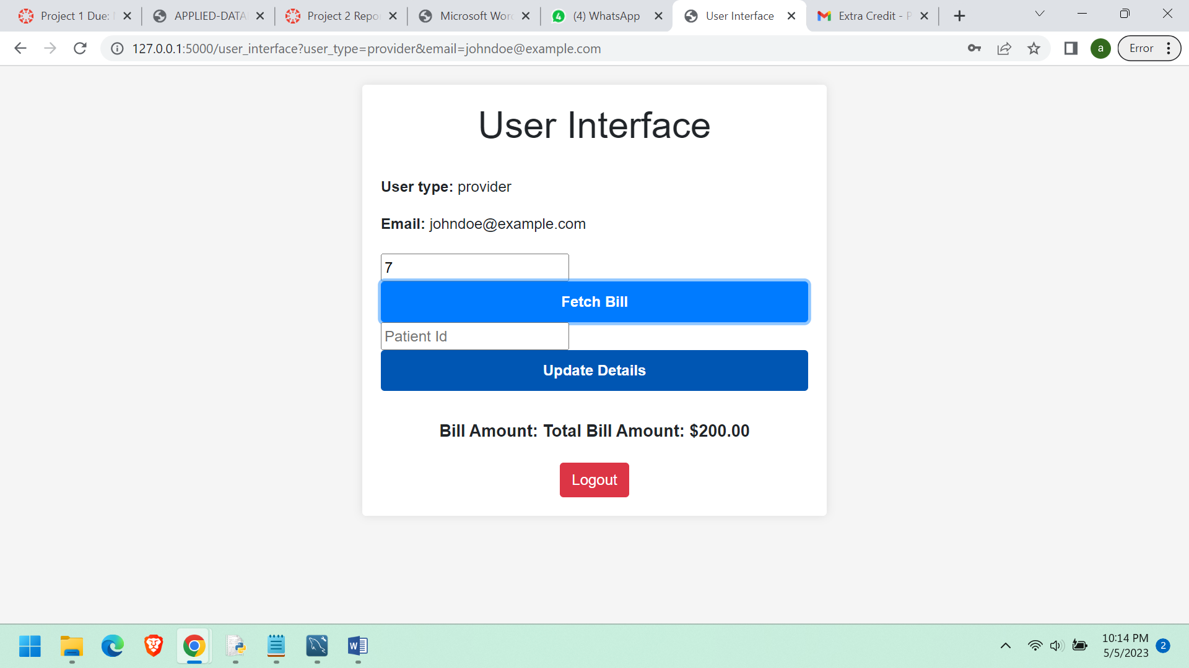

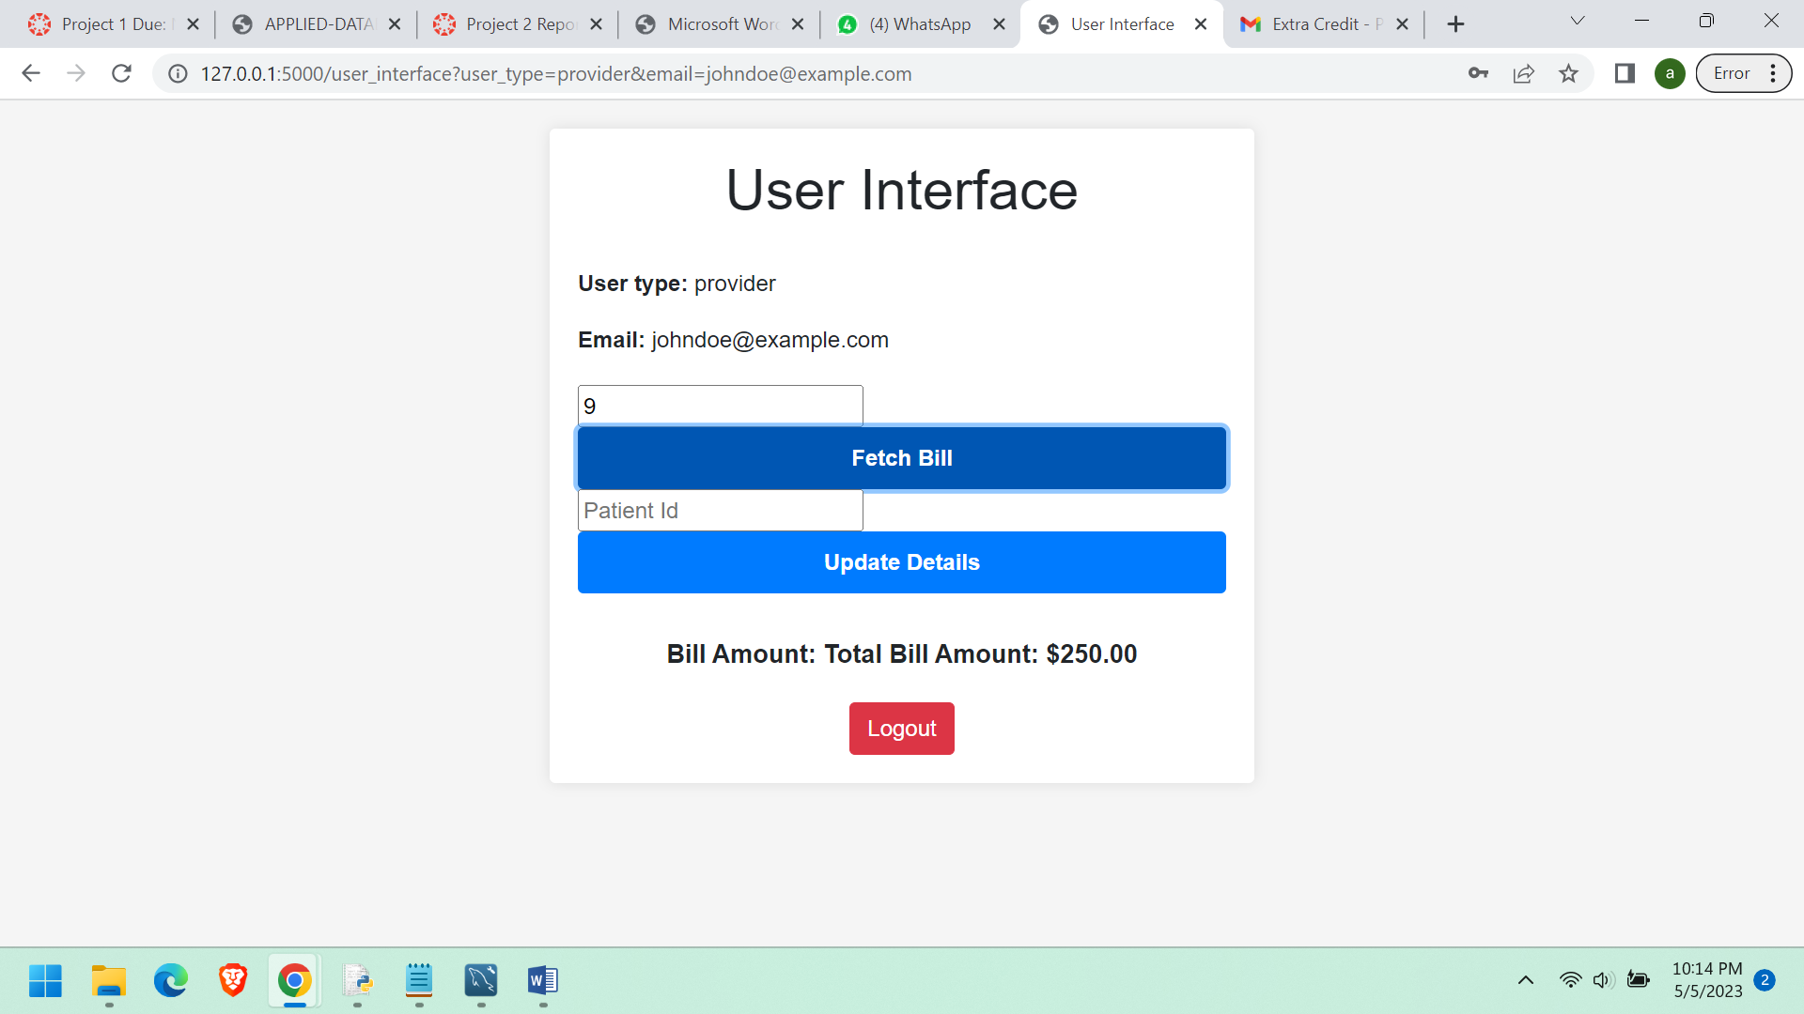

**CAN ALSO UPDATE PATIENT DETAILS.**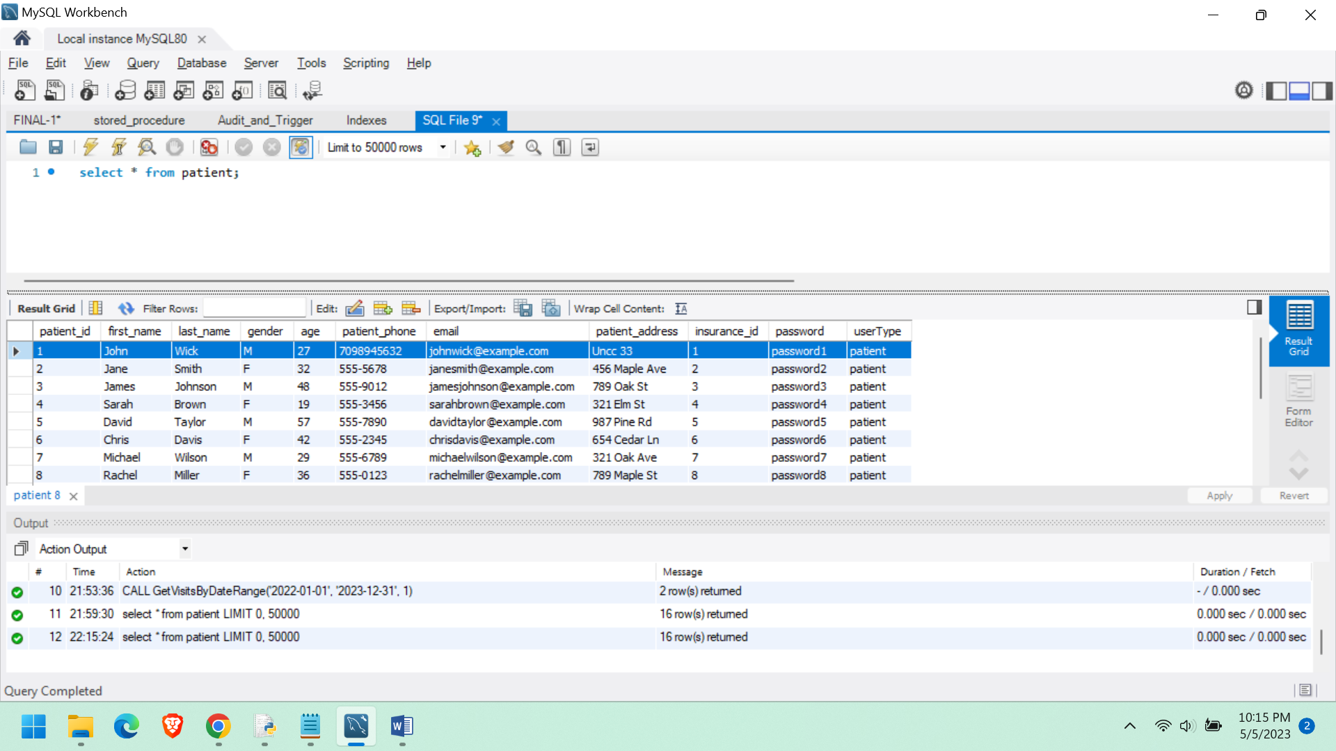

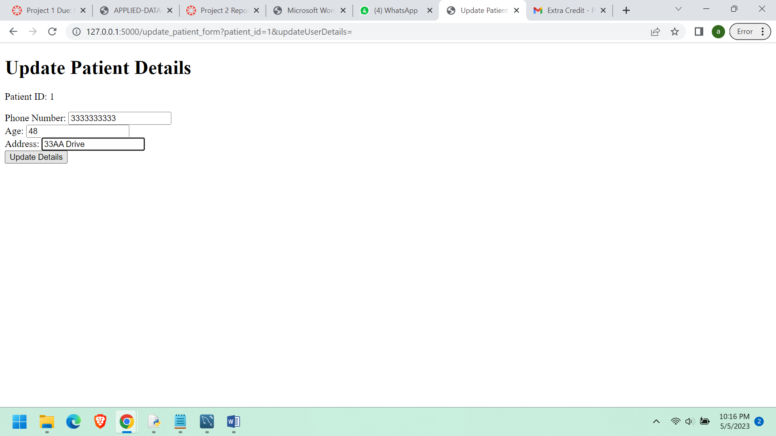

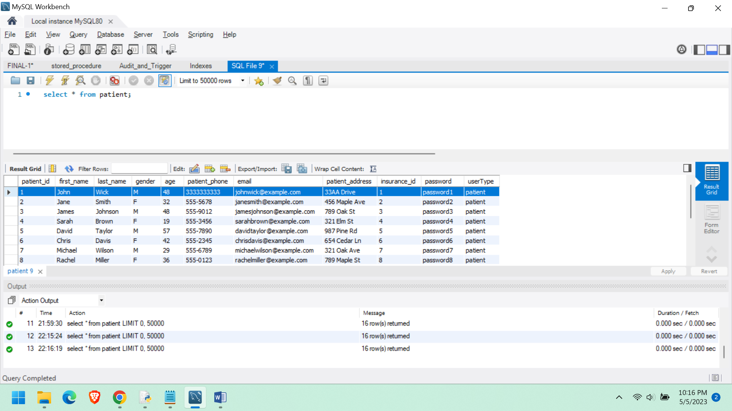

**LETS SEE FOR PATIENT_ID as 6**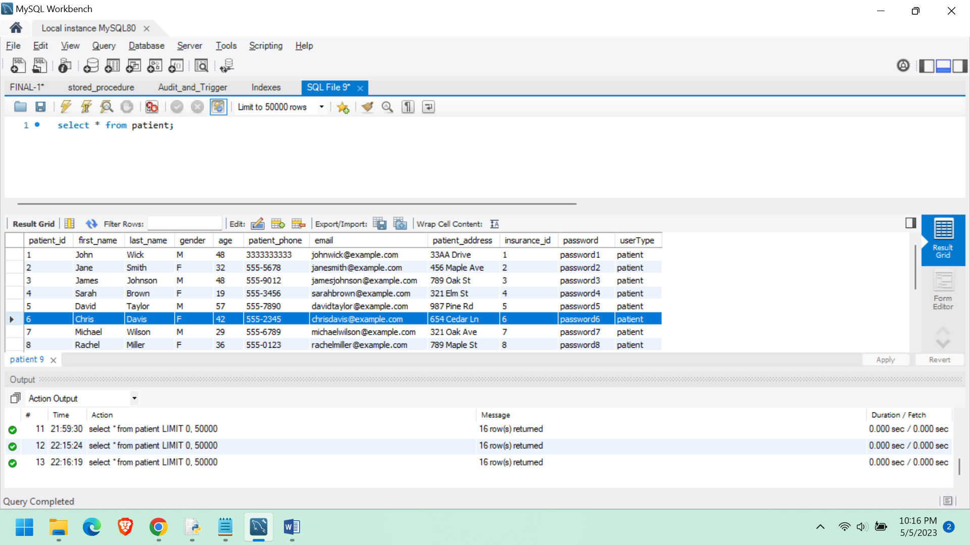

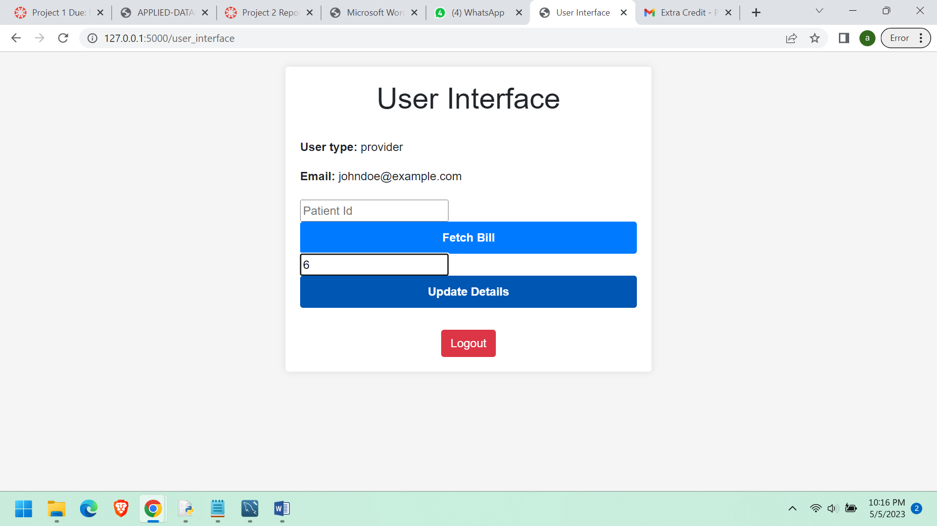

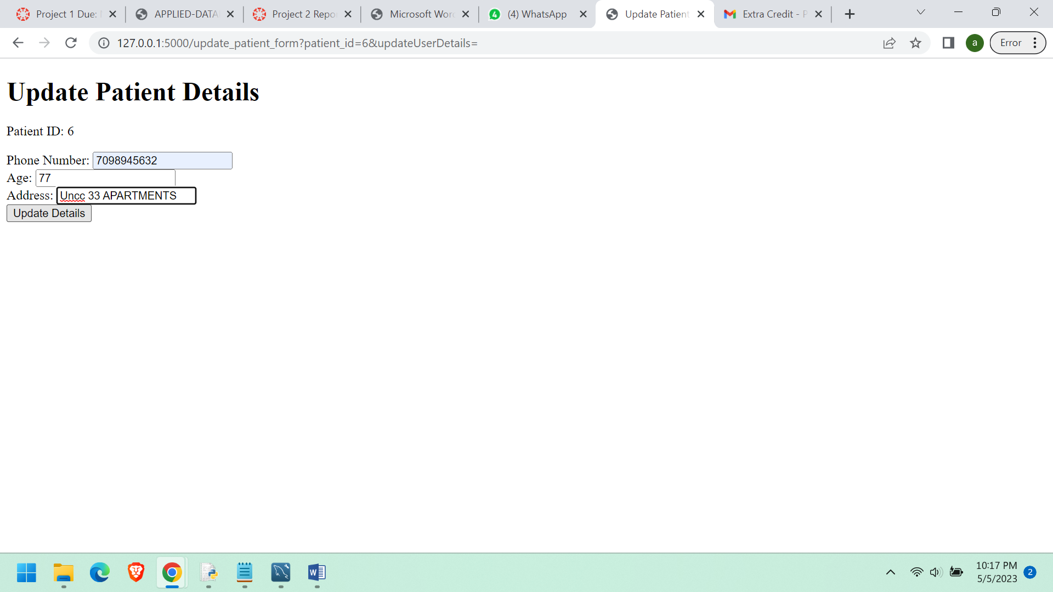

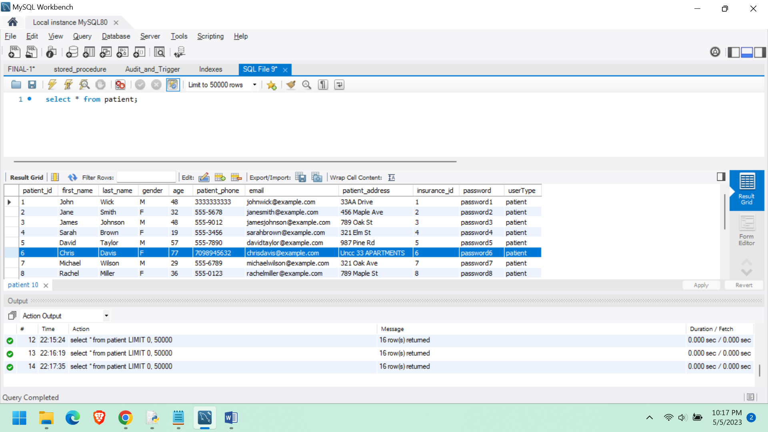

**USER DETAILS ARE UPDATED SUCCESSFULLY.**

**NOW LETS SEE FOR NURSE**

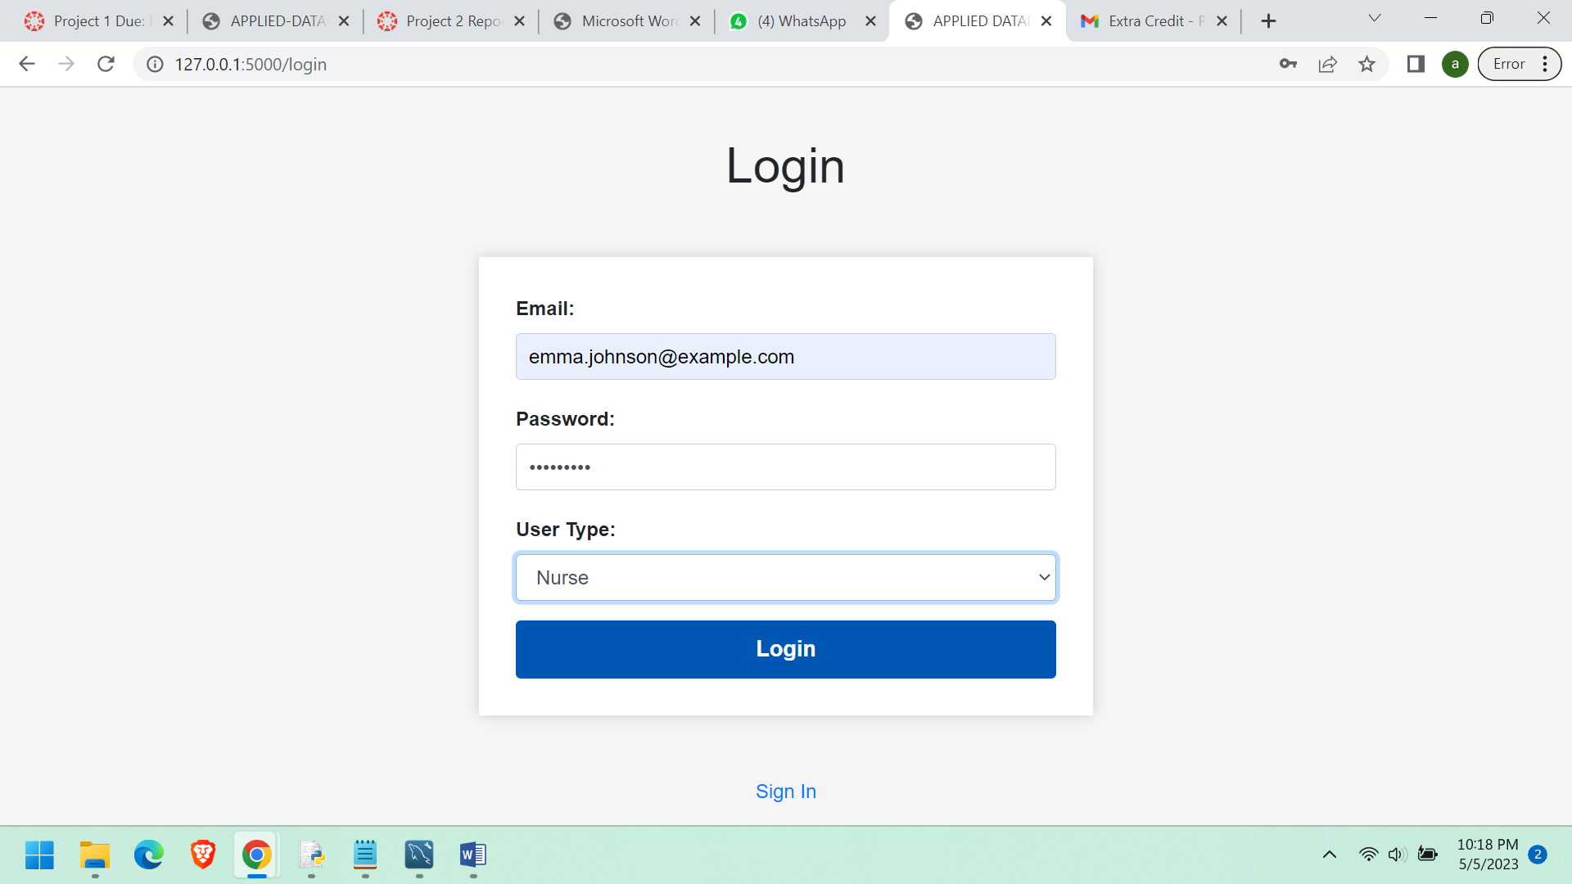

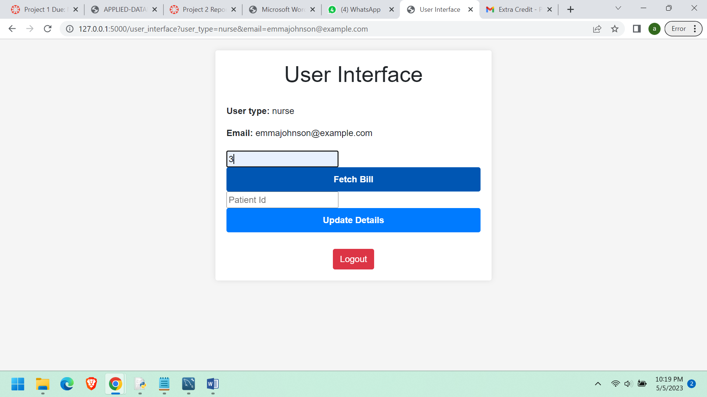

**Nurse can fetch bills.**

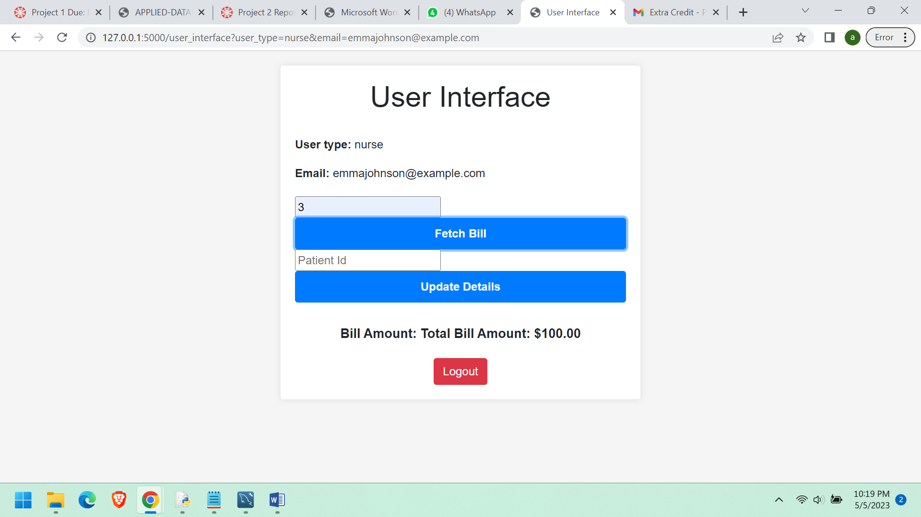

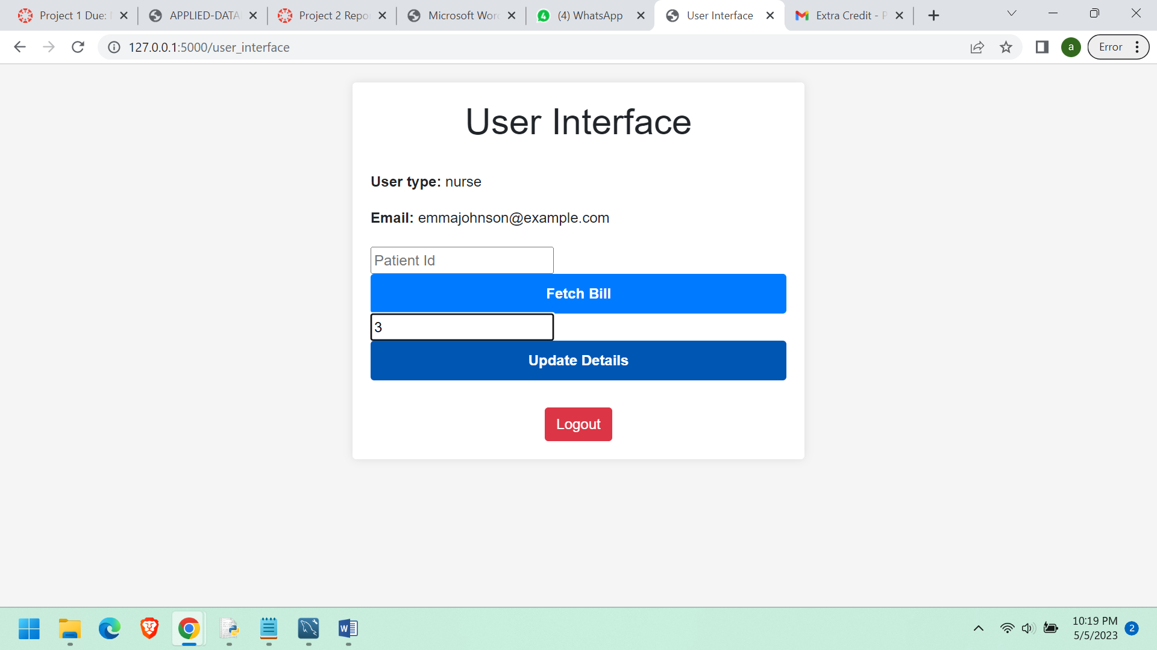

**BUT CANT UPDATE DETAILS.  
  
Shows error message.**

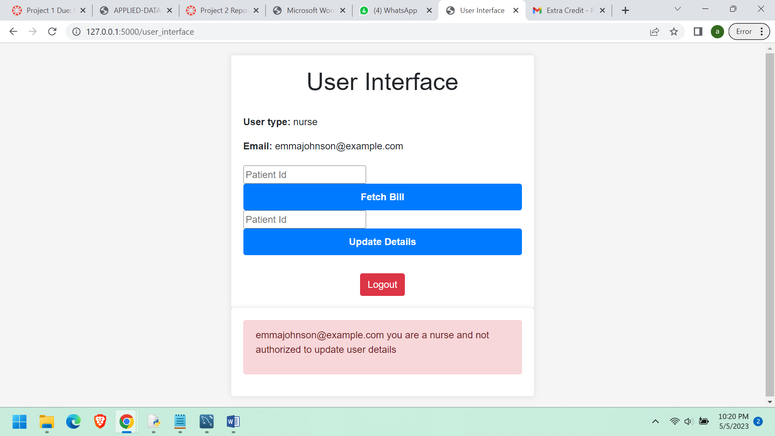

PatientDetailsView: This view provides a summary of all patient details, including their name, address, phone number, email, age, and insurance information.

ProviderDetailsView: This view provides a summary of all provider details, including their name, address, phone number, email, and specialty. NurseDetailsView: This view provides a summary of all nurse details, including their name, address, phone number, email, and room assignments. VisitDetailsView: This view provides a summary of all visit details, including the patient's name, the provider's name, the visit date, and the visit purpose.

I have the following views in the UI.

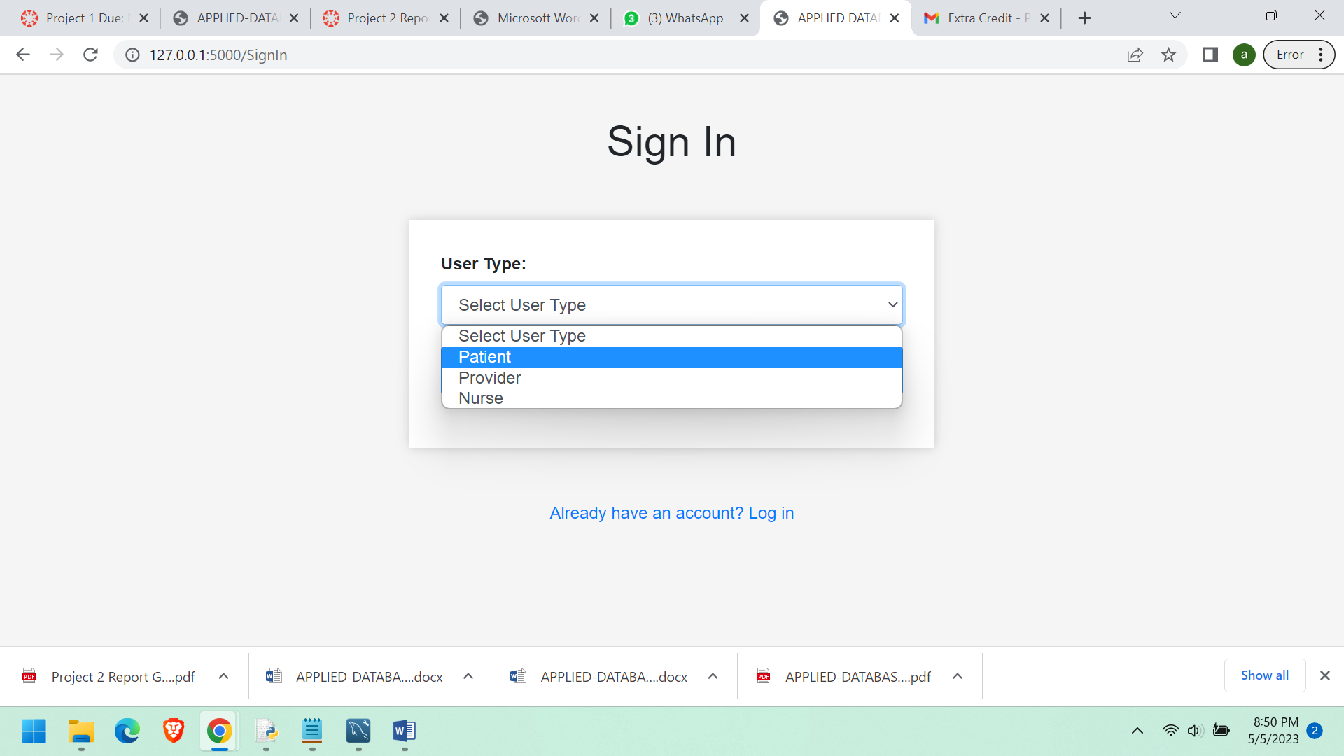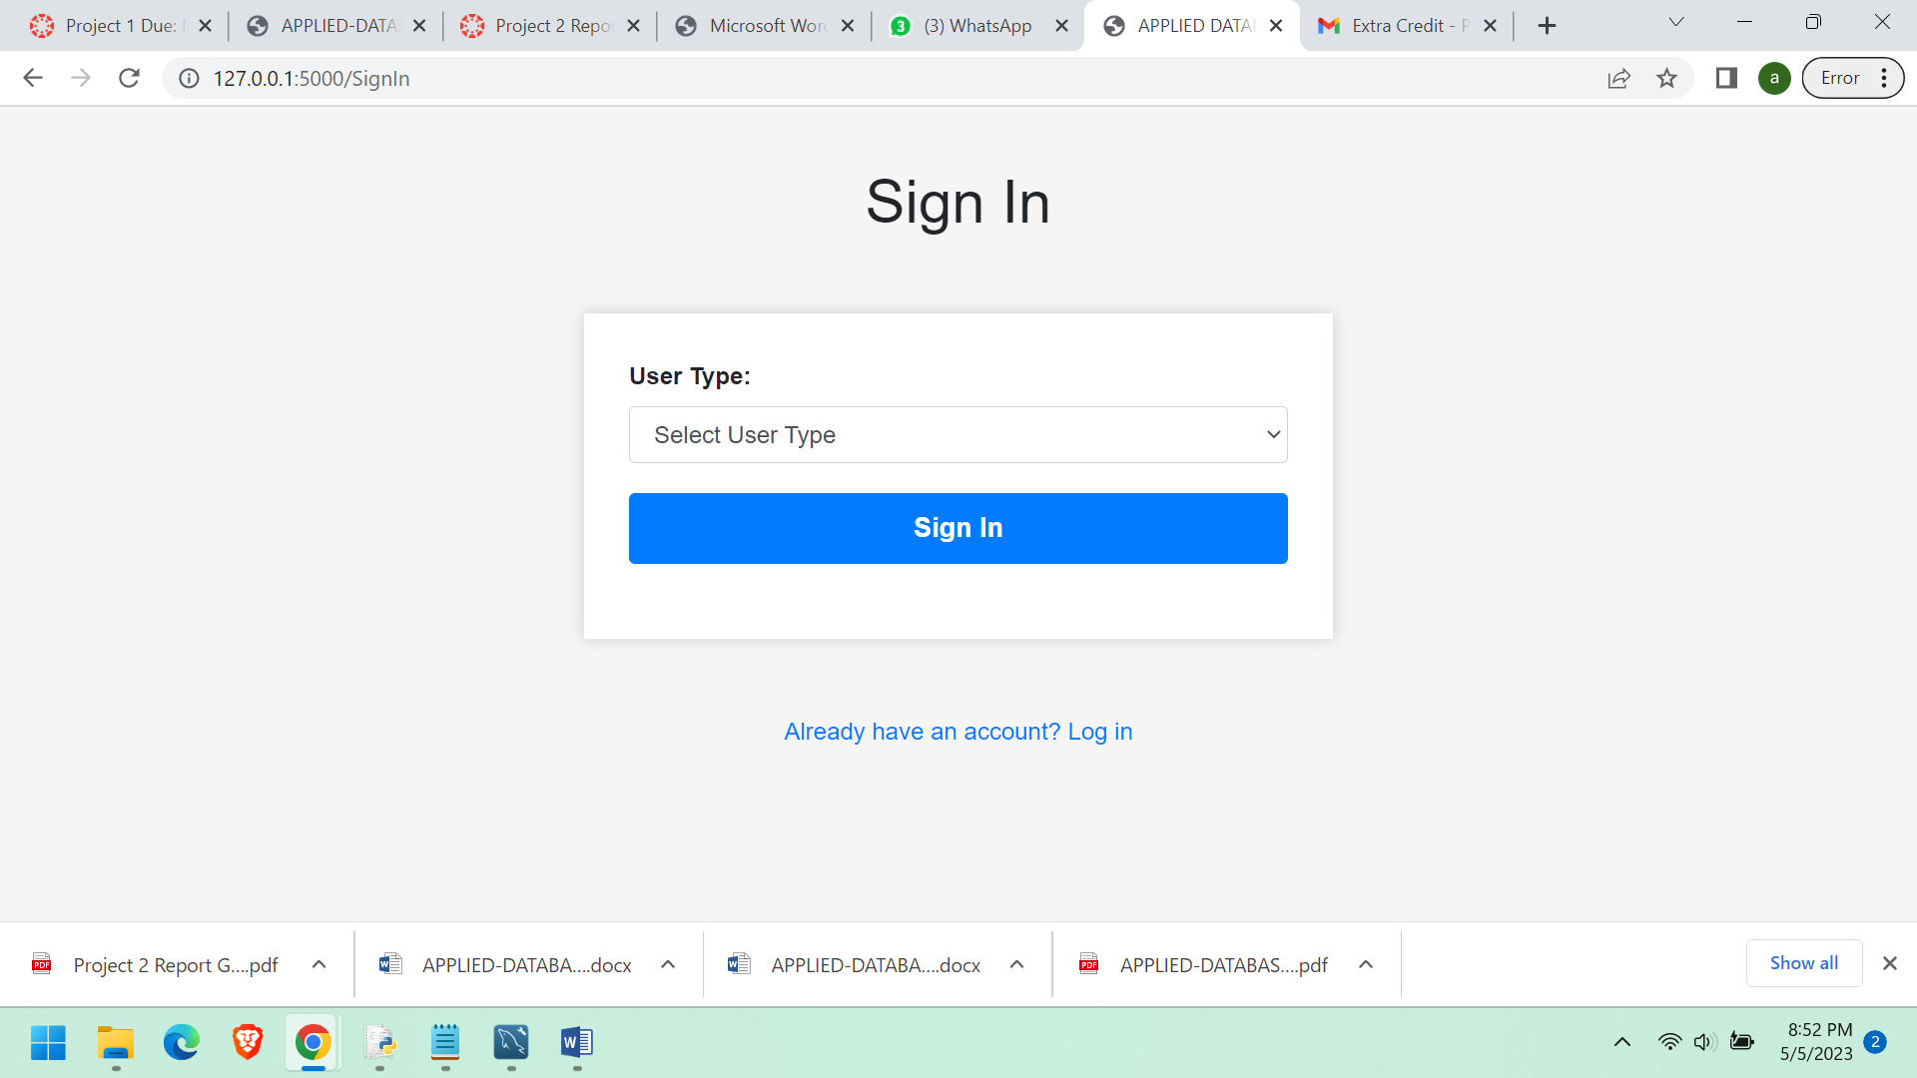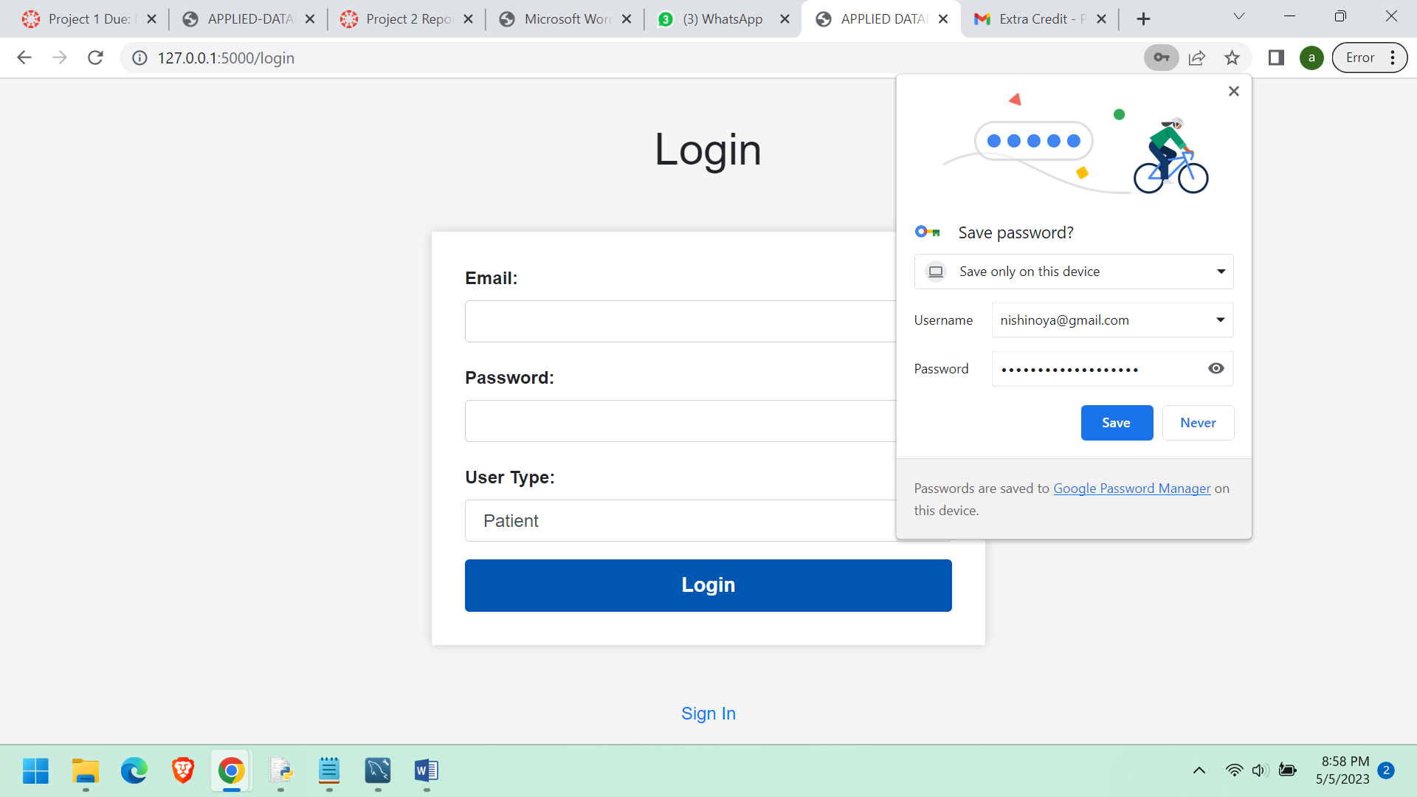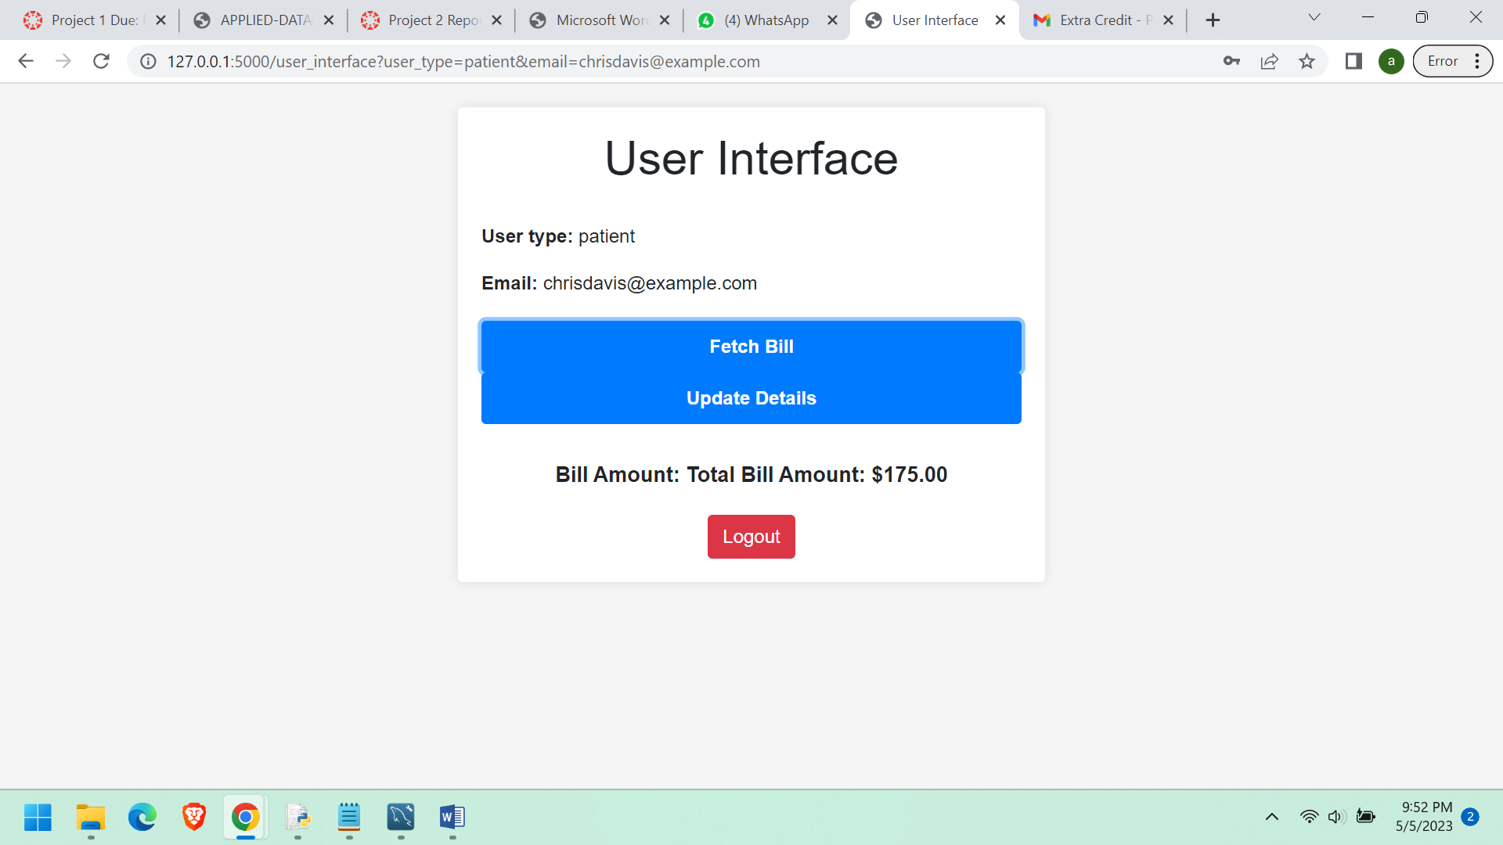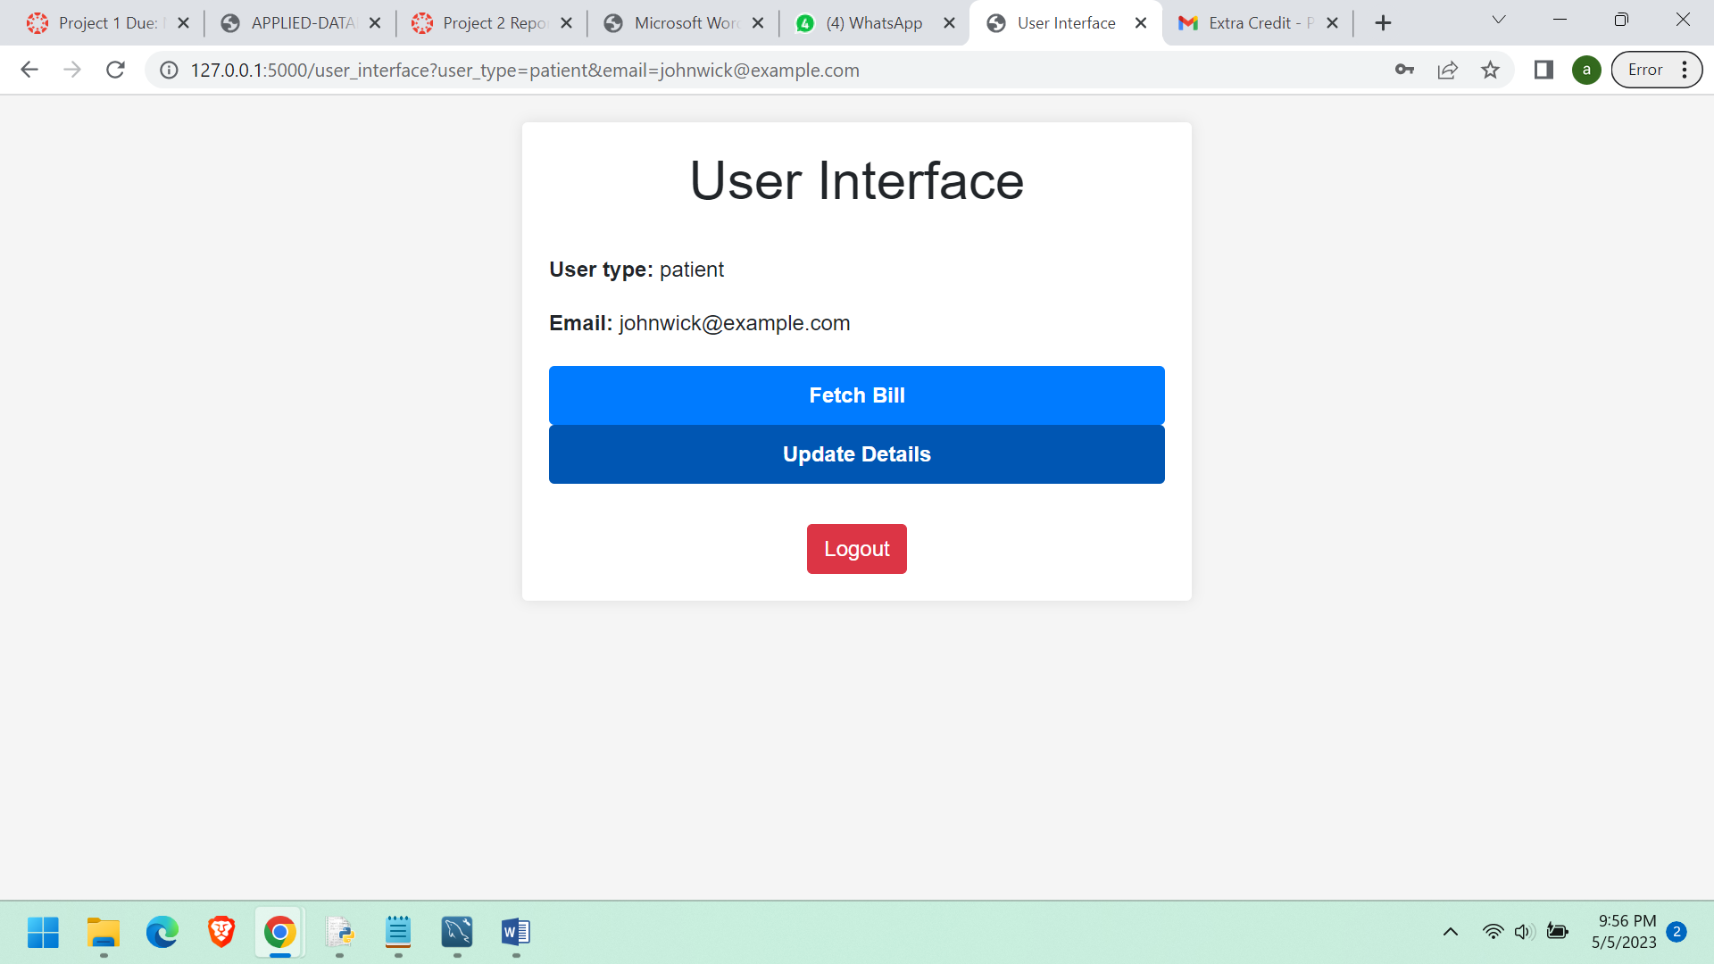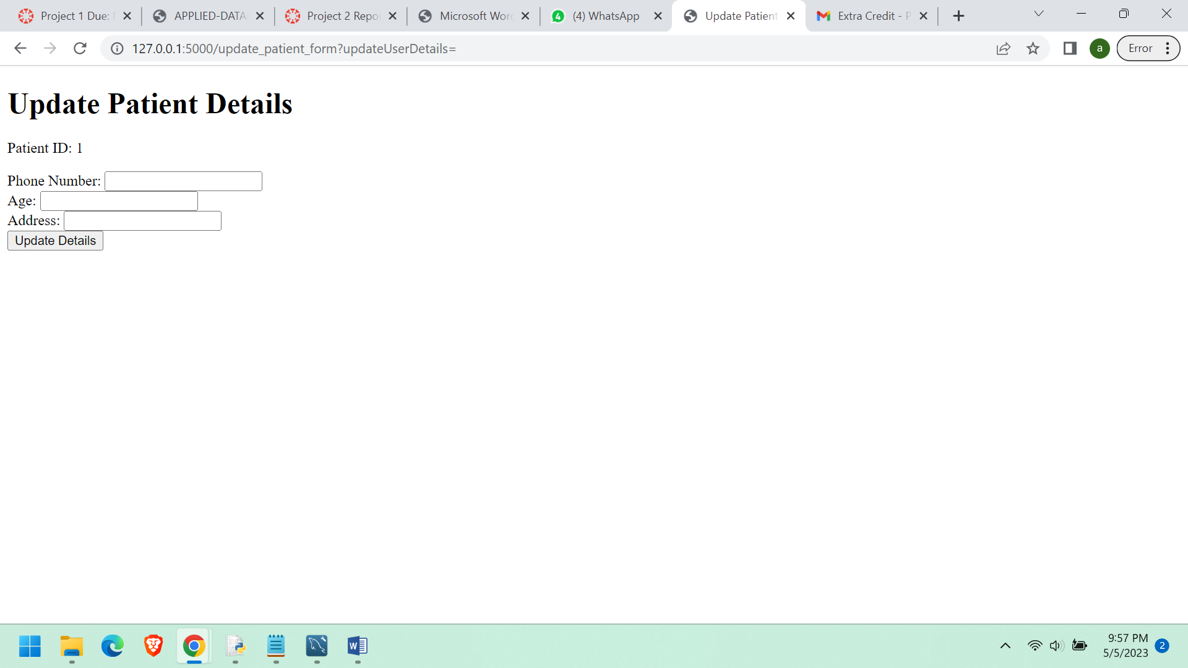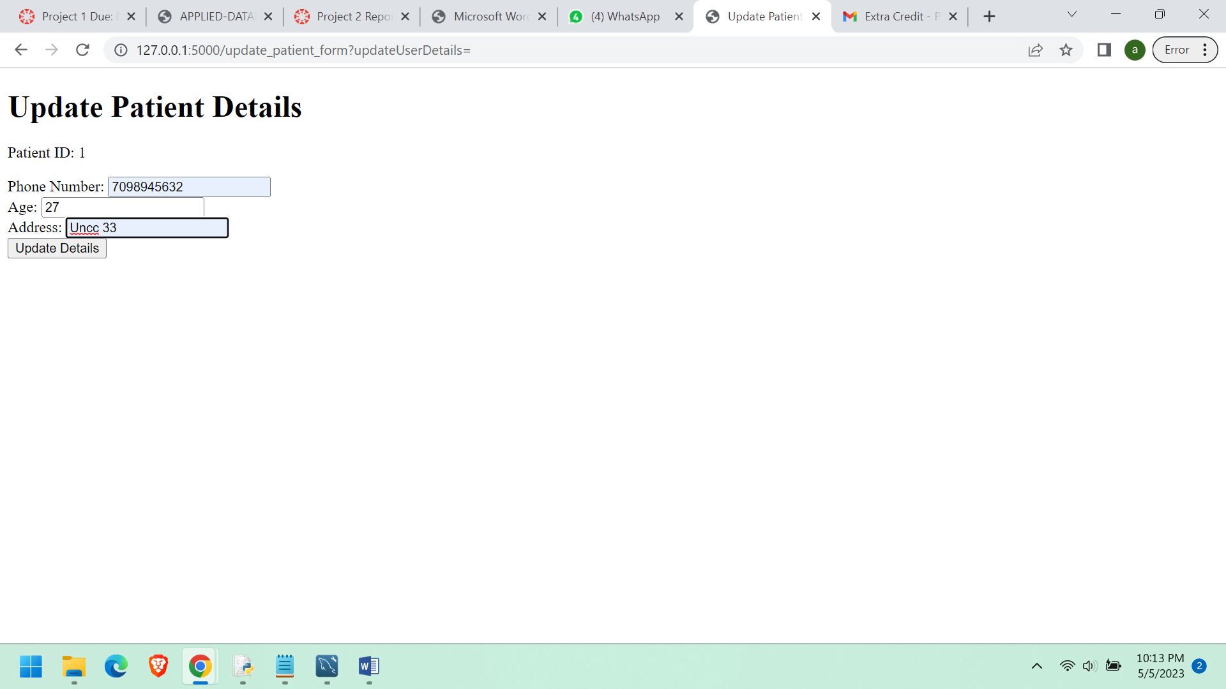

**Indexes:**

**Below are the indexes in the database which are used to faster retrieval of the data**

**■ Definitions and usages/functions**

CREATE INDEX idx_patient_email

ON patient (email);

CREATE INDEX idx_provider_email

ON provider (email);

CREATE INDEX idx_nurse_email

ON nurse (email);

CREATE INDEX idx_billing_amount

ON billing (billing_amount);

CREATE INDEX idx_patient_age

ON patient (age);

CREATE INDEX idx_insurance_id

ON Insurance (insurance_id);

CREATE INDEX idx_insurance_company

ON Insurance (insurance_company);

CREATE INDEX idx_insurance_group ON Insurance (insurance_group);

CREATE INDEX idx_insurance_coverage ON Insurance (insurance_coverage);

CREATE INDEX idx_patient_id ON Patient (patient_id);

CREATE INDEX idx_insurance_id2 ON Patient (insurance_id);

CREATE INDEX idx_visit_id

ON Visit (visit_id);

CREATE INDEX idx_patient_id2

ON Visit (patient_id);

CREATE INDEX idx_provider_id ON Visit (provider_id);

CREATE INDEX idx_priority_id ON Priority (priority_id);

CREATE INDEX idx_visit_id2 ON Priority (visit_id);

CREATE INDEX idx_nurse_id ON Nurse (nurse_id);

CREATE INDEX idx_visit_id3 ON Nurse (visit_id);

CREATE INDEX idx_priority_id2 ON Nurse (priority_id);

CREATE INDEX idx_number_id

ON Room (number_id);

CREATE INDEX idx_nurse_id2

ON Room (nurse_id);

CREATE INDEX idx_provider_id2

ON Medicine (provider_id);

CREATE INDEX idx_medicine_id

ON Billing (medicine_id);

CREATE INDEX idx_patient_id3

ON Billing (patient_id);

The purpose of creating indexes on specific columns is to speed up the search and retrieval of data based on those columns. When a query is executed that involves a column that has an index, the database engine can quickly locate the relevant rows of data instead of scanning the entire table. This can significantly improve the performance of the database.

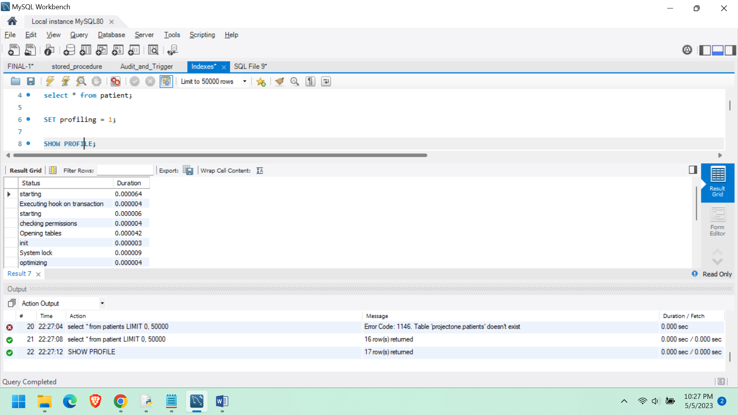

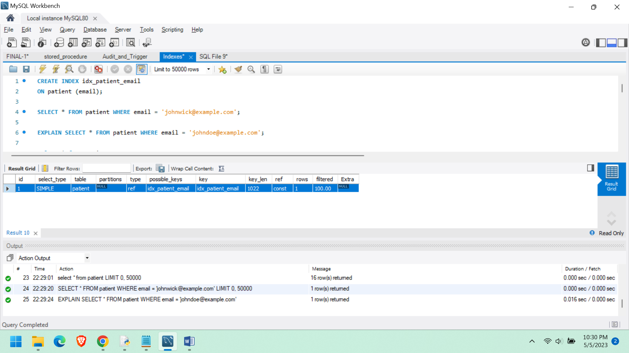

**○ Audit Trails**

**new_patient_details**

DROP TABLE IF EXISTS new_patient_details;

-- Create the audit table

CREATE TABLE new_patient_details (

patient_id INT ,

old_phone_number VARCHAR(100),

new_phone_number VARCHAR(100),

tabl_name VARCHAR(100),

timestamp DATETIME,

user VARCHAR(100)

);

-- Create the trigger

DROP TRIGGER IF EXISTS UPDATE_USER_DETAILS;

DELIMITER //

CREATE TRIGGER UPDATE_USER_DETAILS

BEFORE UPDATE ON patient

FOR EACH ROW

BEGIN

IF OLD.patient_phone <> NEW.patient_phone THEN

INSERT INTO new_patient_details (patient_id, old_phone_number, new_phone_number, tabl_name, timestamp, user)

VALUES (OLD.patient_id, OLD.patient_phone, NEW.patient_phone, "patient", NOW(), USER());

END IF;

END //

DELIMITER ;

select * from new_patient_details;

**This audit table will look after the changes made in the patient table and keeps track of the phone numbers in the table.**

|  |  |  |  |  |  |
| --- | --- | --- | --- | --- | --- |
| 1 | 1234567890 | +1 908 123 743 | patient | 2023-05-05 21:59:14 | root@localhost |
| 1 | +1 908 123 743 | 2222222222 | patient | 2023-05-05 22:13:07 | root@localhost |
| 1 | 2222222222 | 7098945632 | patient | 2023-05-05 22:13:35 | root@localhost |
| 1 | 7098945632 | 3333333333 | patient | 2023-05-05 22:16:13 | root@localhost |
| 6 | 555-2345 | 7098945632 | patient | 2023-05-05 22:17:29 | root@localhost |

**these are the recent changes that are done to various patient_ids by users.**

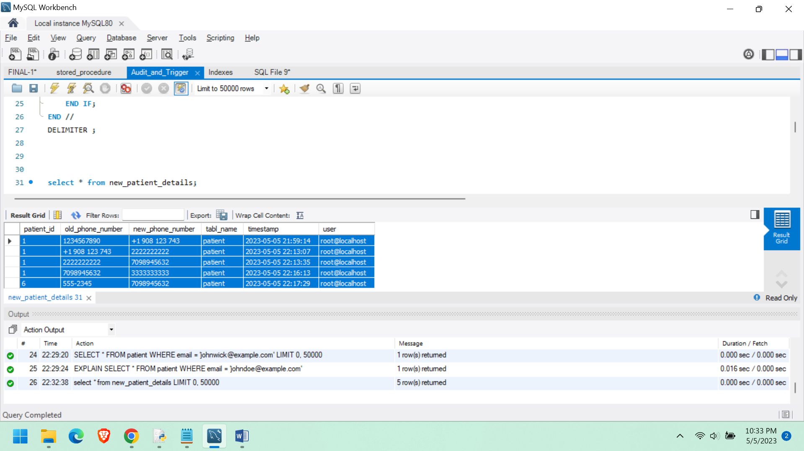

**new_patient_age_details AUDIT TABLE.**

DROP TABLE IF EXISTS new_patient_age_details ;

-- Create the audit table

CREATE TABLE new_patient_age_details (

patient_id int,

old_data_age int,

new_data_age int,

tabl_name VARCHAR(100),

timestamp DATETIME,

user VARCHAR(100)

);

-- Create the trigger

DROP TRIGGER IF EXISTS UPDATE_USER_AGE_DETAILS;

DELIMITER //

CREATE TRIGGER UPDATE_USER_AGE_DETAILS

BEFORE UPDATE ON patient

FOR EACH ROW

BEGIN

IF OLD.age <> NEW.age THEN

INSERT INTO new_patient_age_details (patient_id, old_data_age, new_data_age, tabl_name, timestamp, user)

VALUES (OLD.patient_id, OLD.age, NEW.age, "patient", NOW(), USER());

END IF;

END //

DELIMITER ;

select * from new_patient_age_details;

**This audit table will look after the changes made in the patient table and keeps track of the age in the table.**

|  |  |  |  |  |  |
| --- | --- | --- | --- | --- | --- |
| 1 | 25 | 42 | patient | 2023-05-05 21:59:14 | root@localhost |
| 1 | 42 | 20 | patient | 2023-05-05 22:13:07 | root@localhost |
| 1 | 20 | 27 | patient | 2023-05-05 22:13:35 | root@localhost |
| 1 | 27 | 48 | patient | 2023-05-05 22:16:13 | root@localhost |
| 6 | 42 | 77 | patient | 2023-05-05 22:17:29 | root@localhost |

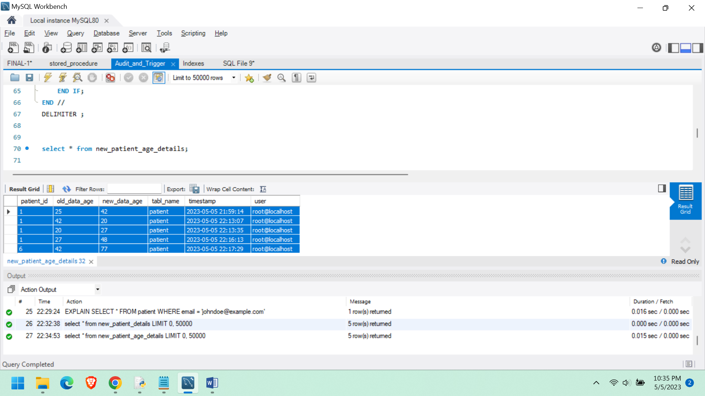

**new_patient_address_details AUDIT TABLE**

DROP TABLE IF EXISTS new_patient_address_details ;

-- Create the audit table

CREATE TABLE new_patient_address_details (

patient_id int,

old_data_address varchar(200),

new_data_address varchar(200),

tabl_name VARCHAR(100),

timestamp DATETIME,

user VARCHAR(100)

);

-- Create the trigger

DROP TRIGGER IF EXISTS UPDATE_USER_ADDRESS_DETAILS;

DELIMITER //

CREATE TRIGGER UPDATE_USER_ADDRESS_DETAILS

BEFORE UPDATE ON patient

FOR EACH ROW

BEGIN

IF OLD.patient_address <> NEW.patient_address THEN

INSERT INTO new_patient_address_details (patient_id, old_data_address, new_data_address, tabl_name, timestamp, user)

VALUES (OLD.patient_id, OLD.patient_address, NEW.patient_address, "patient", NOW(), USER());

END IF;

END //

DELIMITER ;

select * from new_patient_address_details;

**This audit table will look after the changes made in the patient table and keeps track of the address in the table**

|  |  |  |  |  |  |
| --- | --- | --- | --- | --- | --- |
| 1 | New Address | Unc charlotte UT terrace drive | patient | 2023-05-05 21:59:14 | root@localhost |
| 1 | Unc charlotte UT terrace drive | UNCC | patient | 2023-05-05 22:13:07 | root@localhost |
| 1 | UNCC | Uncc 33 | patient | 2023-05-05 22:13:35 | root@localhost |
| 1 | Uncc 33 | 33AA Drive | patient | 2023-05-05 22:16:13 | root@localhost |
| 6 | 654 Cedar Ln | Uncc 33 APARTMENTS | patient | 2023-05-05 22:17:29 | root@localhost |

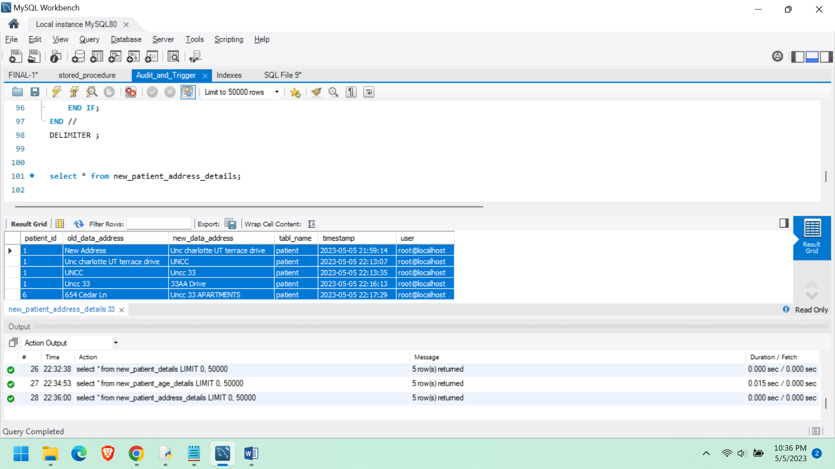

**Tools Used:**

MySQL

Workbench Notepad++

Python IDLE

Microsoft Word

**References:**

Murach’s MYSQL 3rd Edition